A MINI PROJECT REPORT ON

**HEART DISEASE PREDICTION USING ML**

A dissertation submitted in partial fulfilment of the

Requirements for the award of the degree of

**BACHELOR OF TECHNOLOGY**

in

**INFORMATION TECHNOLOGY**

***Submitted by***

**Sree Tulasi Shevva(18B81A1240)**

**Srilasya Punna (18B81A1241)**

**Sriya Mamellapally (18B81A1243)**

***Under the esteemed guidance of***

**Dr.Bipin Bihari Jayasingh**

HOD, IT Department

CVR College of Engineering



**DEPARTMENT OF INFORMATION TECHNOLOGY**

**CVR COLLEGE OF ENGINEERING**

ACCREDITED BY NBA, AICTE & Affiliated to JNTU-H

Vastunagar, Mangalpally (V), Ibrahimpatnam (M), R.R. District, PIN-501 510

**2021-2022**

 **DEPARTMENT OF INFORMATION TECHNOLOGY**

**CERTIFICATE**

This is to certify that the Project Report entitled **“Heart Disease Prediction Using ML”** is a bonafide work done and submitted by **Sree Tulasi Shevva (18B81A1240)**, **Srilasya Punna (18B81A1241)**, **Sriya Mamellapally (18B81A1243)** during the academic year 2021-2022, in partial fulfilment of requirement for the award of Bachelor of Technology degree in Information Technology from Jawaharlal Nehru Technological University Hyderabad, is a bonafide record of work carried out by them under my guidance and supervision.

Certified further that to the best of my knowledge, the work in this dissertation has not been submitted to any other institution for the award of any degree or diploma.

**INTERNAL GUIDE HEAD OF THE DEPARTMENT Dr. Bipin Bihari Jayasingh Dr. Bipin Bihari Jayasingh**

HOD, IT Department HOD, IT Department

**PROJECT COORDINATOR**

**G.Sunitha Rekha**

Associate Professor, IT Department  **EXTERNAL EXAMINER**

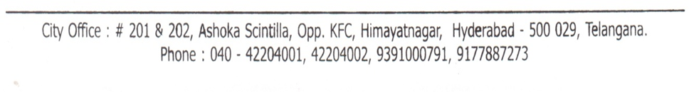

**ACKNOWLEDGEMENT**

The satisfaction of completing this project would be incomplete without mentioning our gratitude towards all the people who have supported us. Constant guidance and encouragement have been instrumental in the completion of this project.

First and Foremost, We thank the Chairman, Principal, Vice Principal for availing infrastructural facilities to complete the mini project in time.

We offer our sincere gratitude to our internal guide **Dr. Bipin Bihari Jayasingh,** Professor, IT Department, CVR College of Engineering for his immense support, timely co-operation and valuable advice throughout the course of our project work.

We would like to thank the Professor In-Charge of Projects, **Dr. B Vikranth**, Professor, Information Technology for his valuable suggestions in implementing the project.

We would like to thank the Head of Department, Professor **Dr. Bipin Bihari Jayasingh**, for his meticulous care and cooperation throughout the project work.

We are thankful to **G. Sunitha Rekha,** Project Coordinator, Associate Professor, IT Department, CVR College of Engineering for his supportive guidelines and for having provided the necessary help for carrying forward this project without any obstacles and hindrances.

We also thank the **Project Review Committee Members** for their valuable suggestions.

**DECLARATION**

We hereby declare that the project report entitled “**Heart Disease Prediction Using ML**” is an original work done and submitted to IT Department, CVR College of Engineering, affiliated to Jawaharlal Nehru Technological University Hyderabad, Hyderabad in partial fulfilment of the requirement for the award of Bachelor of Technology in **Information Technology** and it is a record of bonafide project work carried out by us under the guidance of **Dr.Bipin Bihari Jayasingh, HOD, Department of Information Technology.**

We further declare that the work reported in this project has not been submitted, either in part or in full, for the award of any other degree or diploma in this institute or any other Institute or University.

________________________

Signature of the Student

(Sree Tulasi Shevva)

(18B81A1240)

_____________________

Signature of the Student

(Srilasya Punna)

(18B81A1241)

_____________________

Signature of the Student

(Sriya Mamellapally) (18B81A1243)

**ABSTRACT**

Heart disease, alternatively known as cardiovascular disease, encases various conditions that impact the heart and is the primary basis of death worldwide over the span of the past few decades. It associates many risk factors in heart disease and a need of the time to get accurate, reliable, and sensible approaches to make an early diagnosis to achieve prompt management of the disease . Many researchers, in recent times, have been using several machine learning techniques to help the healthcare industry and the professionals in the diagnosis of heart related diseases. Machine Learning algorithms and techniques have been applied to various medical datasets to automate the analysis of large and complex data. However using data mining techniques can reduce the number of tests that are required. In order to reduce the number of deaths from heart diseases there has to be a quick and efficient detection technique. This disease is quite common nowadays. We used different attributes which can relate to these heart diseases well to find the better method to predict and we also used algorithms for prediction. The goal of this study is to extract hidden patterns by applying data mining techniques, which are noteworthy to heart diseases and to predict the presence of heart disease in patients where this presence is valued from no presence to likely presence i.e The user’s diagnosis test values of various attributes are collected and tested against the available data , which would give us an accurate result of whether the user needs aid to be prone of the heart diseases or not.

**LIST OF FIGURES**

|  |  |  |
| --- | --- | --- |
| **Fig no.** | **Title** | **Pg no.** |
| 1 | Accuracies of algorithms | 17 |
| 2 | Data flow diagram | 21 |
| 3 | Class diagram | 22 |
| 4 | Sequence diagram | 23 |
| 5 | Use case diagram | 24 |
| 6 | Activity diagram | 25 |
| 7 | Component diagram | 26 |
| 8 | State chart diagram | 27 |
| 9 | Collaboration diagram | 28 |
| 10 | Deployment diagram | 28 |
| 11 | System Architecture | 29 |
| 12 | Decision Tree problem | 31 |
| 13 | Decision Tree example | 32 |
| 14 | Decision Tree algorithm | 33 |
| 15 | Decision Tree code snippet | 33 |
| 16 | Decision Tree confusion matrix | 34 |
| 17 | Random Forest code snippet | 35 |
| 18 | Random Forest confusion matrix | 35 |
| 19 | KNN code snippet | 36 |

|  |  |  |
| --- | --- | --- |
| 20 | KNN confusion matrix | 37 |
| 21 | Home page | 37 |
| 22 | Register page | 38 |
| 23 | Login page | 39 |
| 24 | Enter the diagnosis test values page | 39 |
| 25 | Result page | 40 |
| 26 | Logos of various tools used | 45 |
| 27 | Various technologies used | 46 |
| 28 | Name field empty alert | 48 |
| 29 | Email field empty alert | 49 |
| 30 | Email format incorrect alert | 49 |
| 31 | Password length should be at least 6 characters alert | 50 |
| 32 | Password length should not be greater than 20 characters alert | 50 |
| 33 | Password should have at least one uppercase letter alert | 51 |
| 34 | Password should have at least one number alert | 51 |
| 35 | Password should have at least one lowercase letter alert | 52 |
| 36 | Password should have at least one symbol alert | 52 |
| 37 | Already existing user alert | 53 |
| 38 | Invalid credentials alert | 53 |
| 39 | Login before prediction alert | 54 |

|  |  |  |
| --- | --- | --- |
| 40 | Login first alert | 54 |
| 42 | Downloading Python | 60 |
| 43 | Downloading PyCharm | 61 |
| 44 | Downloading Anaconda | 61 |
| 45 | Jupyter notebook command | 62 |
| 46 | Run all cells | 62 |
| 47 | Run Flask | 63 |
| 48 | Home page | 64 |
| 49 | Register page | 65 |
| 50 | Login page | 65 |
| 51 | Prediction page | 66 |
| 52 | Logout page | 66 |

**LIST OF TABLES**

|  |  |  |
| --- | --- | --- |
| **Table. No** | **Title** | **Pg.No** |
| 1 | Heart disease - types | 11 |
| 2 | Algorithms vs accuracies | 17 |

**TABLE OF CONTENTS**

**S. No Topic Pg. No**

1. **Introduction………………………………………. 11**
2. **Software Requirement Specifications………….... 15**
3. **Design…………………………………………….... 20**
4. **Implementation………………………………….... 30**
5. **Testing……………………………………………… 48**

**Conclusion…………………………………… 56**

**Future Enhancements………………………. 57**

**References…………………………………….. 58**

**Appendix A - Abbreviations………………….. 59**

**Appendix B - Software InstallationProcedure.. 60**

**Appendix C – Software Usage Process……….. 62**

**CHAPTER 1**

**1. INTRODUCTION**

**1.1 Heart Disease : Types**

Heart disease is the leading cause of mortality in the world over the past few decades . Many predisposing factors such as personal and professional habits and genetic predisposition accounts for heart disease. Various habitual risk factors such as smoking, overuse of alcohol and caffeine, stress, and physical inactivity along with other physiological factors like obesity, hypertension, high blood cholesterol, and pre-existing heart conditions are predisposing factors for heart disease.

Heart disease encompasses a wide range of cardiovascular problems. Several diseases and conditions fall under the umbrella of heart disease. Types of heart disease include:

|  |  |
| --- | --- |
| **Type** | **Description** |
| Arrhythmia | It is a heart rhythm abnormality |
| Atherosclerosis | It is the hardening of arteries |
| Cardiomyopathy | It’s a condition that causes the heart muscles to harden or grow weak |
| Congenital heart defects | They are heart irregularities that are present at birth. |
| Coronary artery disease(CAD)/Ischemic heart disease | It is caused by buildup of plaque in the heart’s arteries. |
| Heart infections | It causes inflammation or damage to your heart's inner lining, valves, outer membrane, or the heart muscle itself. |

**Table 1: Heart disease - types**

**1.2 Symptoms**

The major symptoms for the same include:

* Fluttering in the chest
* Racing heartbeat(tachycardia)
* Slow heartbeat(bradycardia)
* Chest pain or discomfort
* Shortness of breath
* Dizziness or a Syncope

Different types of heart disease may result in a variety of different symptoms.

* **Arrhythmias**
  + Arrhythmias are abnormal heart rhythms. The symptoms you experience may depend on the type of arrhythmia you have — heartbeats that are [too](https://www.healthline.com/symptom/fast-heart-rate) fast or [too](https://www.healthline.com/symptom/slow-heart-rate) slow. Symptoms of an arrhythmia include:
  + lightheadedness
  + fluttering heart or racing heartbeat
  + slow pulse
  + fainting spells
  + dizziness
  + chest pain

### Atherosclerosis

### Atherosclerosis reduces blood supply to your extremities. In addition to chest pain and shortness of breath, symptoms of atherosclerosis include:

* + coldness,especially in the limbs
  + numbness, especially in the limbs.
  + unusual or unexplained pain
  + weakness in your legs and arms.

### Congenital heart defects

* + Congenital heart defects are heart problems that develop when a fetus is growing. Some heart defects are never diagnosed. Others may be found when they cause symptoms, such as:
  + blue-tinged skin
  + swelling of the extremities
  + shortness of breath or difficulty breathing
  + fatigue and low energy irregular heart rhythm.
* **Coronary artery disease (CAD)**
  + CAD is plaque buildup in the arteries that move oxygen-rich blood through the heart and lungs.Symptoms of CAD include:
  + chest pain or discomfort
  + a feeling of pressure or squeezing in the chest
  + shortness of breath
  + nausea
  + feelings of indigestion or gas

### Cardiomyopathy

* + Cardiomyopathy is a disease that causes the muscles of the heart to grow larger and turn rigid, thick, or weak. Symptoms of this condition include:
  + fatigue
  + bloating
  + shortness of breath
  + swollen legs, especially ankles and feet
  + pounding or rapid pulse

### Heart infections

* + The term heart infection may be used to describe conditions such as endocarditis or myocarditis. Symptoms of a heart infection include:
  + chest pain
  + chest congestion
  + fever and chills
  + skin rash

**1.3 Need for a Prediction Model**

The efficient and accurate and early medical diagnosis of heart disease plays a crucial role in taking preventive measures to prevent death. Several different symptoms are associated with heart disease, which makes it difficult to diagnose it quicker and better. Doctor’s knowledge could be used to assign weight to each attribute. More weight is assigned to the attribute having a high impact on disease prediction. Therefore it appears reasonable to try utilizing the knowledge and experience of several specialists collected in databases towards assisting the Diagnosis process. It also provides healthcare professionals an extra source of knowledge for making decisions. The healthcare industry collects large amounts of health-care data and that need to be mined to discover hidden information for effective decision making.

Medical organisations, all around the world, collect data on various health related issues. These data can be exploited using various machine learning techniques to gain useful insights. These datasets, which are too overwhelming for human minds to comprehend, can be easily explored using various machine learning techniques. Thus, these algorithms have become very useful, in recent times, to predict the presence or absence of heart related diseases accurately. Prediction is one area where this machine learning is used,our topic is about prediction of heart disease by processing a patient's dataset and a data of patients to whom we need to predict the chance of occurrence of a heart disease.

**1.4 Literary Survey**

Prediction of heart disease using data mining techniques has been an ongoing effort for the past two decades. Most of the papers have implemented several data mining techniques for diagnosis of heart disease such as Decision Tree, Naive Bayes, neural network, kernel density, automatically defined groups, bagging algorithm and support vector machine showing different levels of accuracies.In particular, researchers have been investigating the application of the Decision Tree technique in the diagnosis of heart disease with considerable success.The decision making process of heart disease is effectively diagnosed by, Random forest algorithm, based on the probability of decision support, the heart disease is predicted.

* Mohammed Abdul Khaleel has given a paper in the Survey of Techniques for mining of data on Medical Data for Finding Frequent Diseases locally. This paper focuses on dissecting information mining procedures which are required for medicinal information mining particularly to find locally visited illnesses, for example, heart infirmities, lung malignancy, bosom disease et cetera.
* Information mining is the way toward extricating information for finding inactive examples which Vembandasamy et al. performed, to analyze and detect heart disease. In this the algorithm used was Naive Bayes algorithm. In the Naïve Bayes algorithm they used the Bayes theorem. Hence Naive Bayes has a lot of power to make assumptions independently. The used data-set is obtained from a diabetic research institute of Chennai, Tamilnadu which is a leading institute. There are more than 500 patients in the dataset. The tool used is Weka and classification is executed by using 70% of Percentage Split. The accuracy offered by Naive Bayes is 86.419%.The objective of this research was to compare the outcomes of the performance of different classification techniques for a heart disease dataset.
* M.A.Nishara Banu and B.Gomathy have given a paper named Disease Predicting system using data mining techniques. In this paper they talk about MAFIA (Maximal Frequent Itemset algorithm) and K-Means clustering. As classification is important for prediction of a disease. The classification based on MAFIA and K-Means results in accuracy.
* Wiharto and Hari Kusnanto have given a paper named Intelligence System for Diagnosis Level of Coronary Heart Disease with K-Star Algorithm. In this paper they exhibit an expectation framework for heart infection utilizing Learning vector Quantization neural system calculation.

**1.5 Limitation**

* Considering the limitations of this study, there is a need to implement more complex and combination of models to get higher accuracy for early prediction of heart disease.

**CHAPTER 2**

**2. SOFTWARE REQUIREMENT SPECIFICATIONS**

**2.1 Functional Requirements**

* Model takes necessary information from the user

The basic overview of the model is to collect data from the user and use the same to be compared with the previously collected data to predict the chances of occurrence of a cardiovascular disease.Thus, the model includes the primary step of collecting data from the user. The data required here are the diagnosis test values of the various attributes as mentioned in the dataset. The same include **:** age, sex, chest pain type, resting blood pressure, cholesterol, fasting blood sugar, rest electrocardiographic result, max heart rate, exercise induced angina, ST depression induced by exercise relative to rest, Slope of the peak exercise ST segment, Number of major vessels coloured by fluoroscopy, thal.

* Processing the input and generation of test results

The user enters the diagnosis results which are taken as the input and they are tested against various ML algorithms. Here three algorithms have been used which include the Random Forest algorithm , the KNN algorithm and the Decision tree algorithm.The test results are then generated , that is the prediction if a person is prone to a heart disease or not.

* Displaying the output in a human readable form

The prediction made is then displayed through a UI to the user. If the test values prove to be accurate for the user being prone to the disease , then a message is popped up saying that” the user has high chances of being vulnerable to a heart disease” , if not , it shows that” the user has low chances of being vulnerable to a heart disease”.

**2.2 Non-Functional Requirements**

* Accuracy

The model here uses three algorithms for the prediction as mentioned above. The accuracy of each algorithm is as follows:

|  |  |
| --- | --- |
| Algorithm | Accuracy |
| Random Forest Classifier | 82% |
| KNN | 86.9% |
| Decision tree | 82% |

**Table 2: Algorithms vs accuracies**

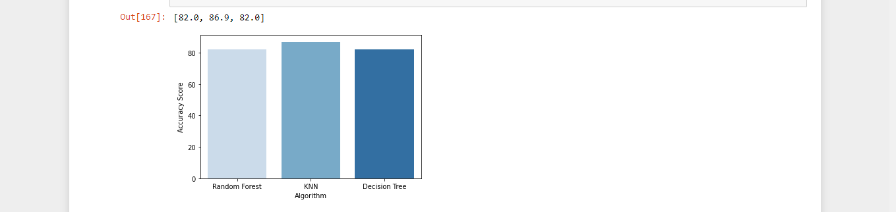

**Fig 1: Accuracies of different algorithms**

* Accessibility

Our model is accessible by performing a simple 2 step process that is registration and login.In our project people who have registered with our application can login and enter the data.User interface is simple and efficient and can be accessed by any person.

* Maintainability

In software engineering, maintainability is the ease with which a software product can be modified in order to include new functionalities in the project based on the user requirements just by adding the appropriate files to existing project.Since python programming is very simple, it is easier to find and correct the defects and to make the changes in the project.

* Scalability

System can work normally under situations such as low bandwidth.

**2.3 Hardware Requirements**

* Our model requires a Linux (Ubuntu 18.04 or equivalent) or Windows(7 or higher) machine with a minimum of 4GB RAM and 50GB disk space.

**2.4 Software Requirements**

● Platform:Jupyter

Jupyter is a free, open-source, interactive web tool known as a computational notebook, which researchers can use to combine software code, computational output, explanatory text and multimedia resources in a single document.

● User Interface:Flask

Flask is an API of Python that allows us to build up web-applications.Flask's framework is easier to learn because it has less base code to implement a simple web-Application.

● Python (NumPy,Pandas,Sklearn)

**Pandas**:Pandas is a python library used for data analysis.It is used to create a dataframe that is a 2D data structure similar to excel sheet.

**Numpy**:Numpy is a python library used to handle multidimensional arrays.

**Matplotlib**:Matplotlib is a 2D plotting library for creating plots and graphs.

**Seaborn**:Seaborn is a Python data visualization library based on matplotlib.It provides a high-level interface for drawing attractive and informative statistical graphics.

**Sklearn**:Scikit-learn is the most useful library for machine learning in Python. The sklearn library contains a lot of efficient tools for machine learning and statistical modeling including classification, regression, clustering and dimensionality reduction.We have used **RandomForestClassifier, DecisionTreeClassifier** and **KNeighbourClassifier**.

● Database:sqlite3

SQLite3 is a very easy to use database engine. It is self-contained, serverless, zero-configuration and transactional. The Python Standard Library includes a module called "sqlite3" intended for working with this database.

**CHAPTER 3**

**3. DESIGN**

We have implemented in our system heart disease prediction using machine learning. This system is built with various designs such as data flow diagram, sequence diagram, class diagram, use case diagram, component diagram, activity diagram, state chart diagram, deployment diagram. After doing these various diagrams and based on these diagrams we have done our project.We have designed our system in such a way that whenever a user logs in into the system,the user has to register to the system, and new users cannot use the system without registering in the system. After that for registration the user requires basic credentials such as username, email, password. Then the user has to login to the system using the same email and password. Here are the things that this system can perform.

a. Entering Symptoms

b. Disease Prediction

Entering Symptoms: Once a user successfully logged in to the system then he/she has to select the symptoms from the given drop-down menu.

Disease prediction: The predictive model predicts the presence of heart disease of a person based on the user entered symptoms.

**3.1 DATA FLOW DIAGRAM**

The data flow diagram of the project disease prediction using machine learning consists of all the various aspects a normal flow diagram requires. This data flow diagram shows how from starting the model flows from one step to another, like he enter into the system then enters all the information's and all other general information along with the symptoms that goes into the system, compares with the prediction model and if true is predicts the appropriate results otherwise it shows the details where the user if gone wrong while entering the information.

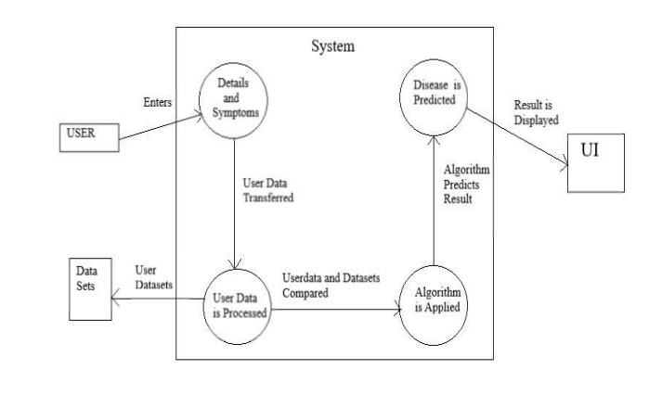

**Fig 2: DataFlow diagram**

**3.2 CLASS DIAGRAM**

Disease prediction using machine learning consists of a class diagram that all the other applications that consist of the basic class diagram, here the class diagram is the basic entity that is required in order to carry on with the project. Class diagram consist information about all the classes that is used and all the related datasets, and all the other necessary attributes and their relationships with other entities, all these information is necessary in order to use the concept of the prediction, where the user will enter all necessary information such as user name, email, phone number, and many more attributes that is required in order to login into the system and using the files concept we will store the information of the users who are registering into the system and retrieves those information later while logging into the system.

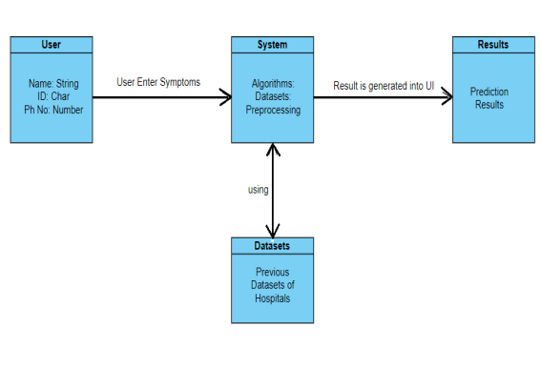

**Fig 3: Class diagram**

**3.3 SEQUENCE DIAGRAM**

The Sequence diagram of the project disease prediction using machine learning consists of all the various aspects a normal sequence diagram requires. This sequence diagram shows how from starting the model flows from one step to another, like he enter into the system then enters all the information's and all other general information along with the symptoms that goes into the system, compares with the prediction model and if true is predicts the appropriate results otherwise it shows the details where the user if gone wrong while entering the information's and it also shows the appropriate precautionary measure for the user to follow. Here the sequence of all the entities are linked to each other where the user gets started with the system.

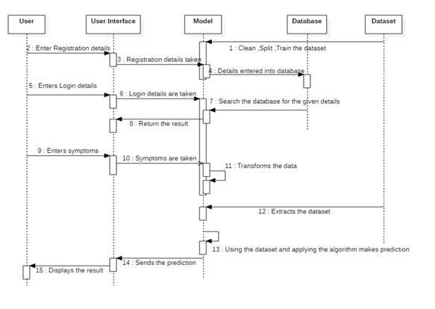

**Fig 4: Sequence diagram**

**3.4 USE CASE DIAGRAM**

The Use Case diagram of the project disease prediction using machine learning consists of all the various aspects a normal use case diagram requires. This use case diagram shows how from starting the model flows from one step to another, like he enter into the system then enters all the information's and all other general information along with the symptoms that goes into the system, compares with the prediction model and if true is predicts the appropriate results otherwise it shows the details where the user if gone wrong while entering the information's and it also shows the appropriate precautionary measure for the user to follow. Here the use case diagram of all the entities are linked to each other where the user gets started with the system.

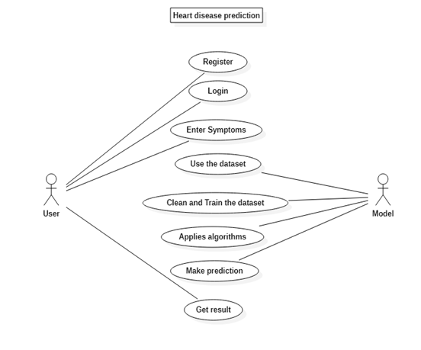

**Fig 5: Use case diagram**

**3.5 ACTIVITY DIAGRAM**

Activity diagram is another important diagram in UML to describe the dynamic aspects of the system. Activity diagram is basically a flowchart to represent the flow from one activity to another activity. The activity can be described as an operation of the system. The control flow is drawn from one operation to another. Here in this diagram the activity starts from the user where the user registers into the system then login using the credentials and then the credentials are matched in the system and if it is true, then the user proceeds to the prediction phase where the prediction happens. Then finally after processing the data from datasets the analysis will happen then the correct result will be displayed that is nothing but the output.

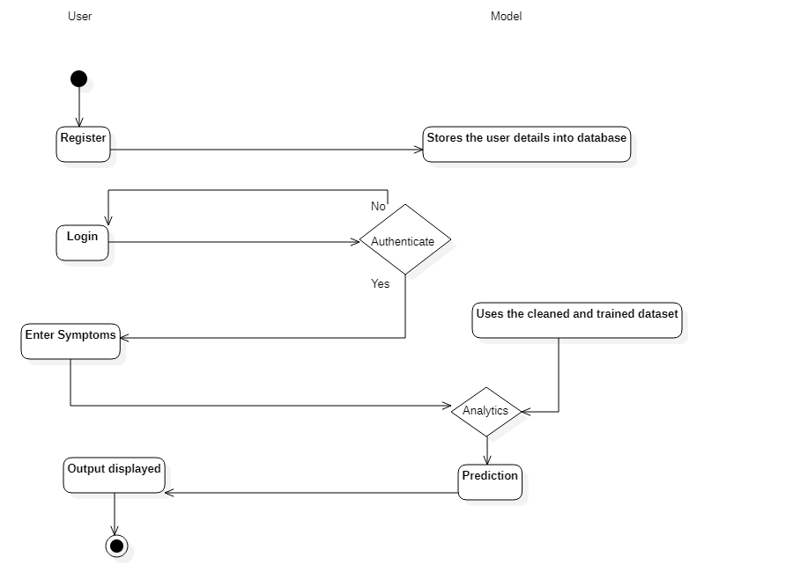

**Fig 6: Activity diagram**

**3.5 COMPONENT DIAGRAM**

A component diagram, also known as a UML component diagram, describes the organization and wiring of the physical components in a system. Component diagrams are often drawn to help model implementation details and double-check that every aspect of the system's required function is covered by planned development. Here the component diagram consists of all major components that are used to build a system. So, Design,Algorithm, File System and Datasets all are linked to one another. Datasets are used to compare the results and an algorithm is used to process those results and give a correct accuracy and design UI is used to show the result in an appropriate way in the system and file system is used to store the user data. So, like this all components are interlinked to each other.

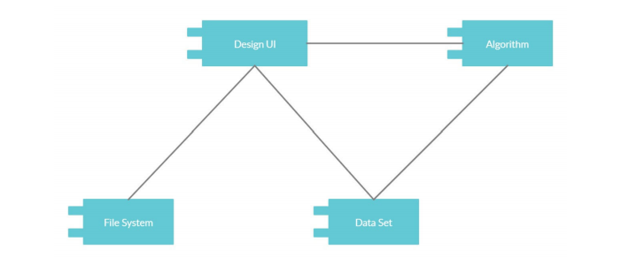

**Fig 7: Component diagram**

**3.6 STATE CHART DIAGRAM**

A State chart diagram describes the behaviour of a single object in response to a series of events in a system. Sometimes it's also known as a Harel state chart or a state machine diagram. This UML diagram models the dynamic flow of control from state to state of a particular object within a system. It is similar to activity diagram but here there are only few rules like how it starts and how it end all are denoted with the help of the symbol given below, the system starts with the registration and then login comes, if the login is successful then it will go to the next step and if login is incorrect then comes back to same page stating incorrect details. After the successful login the user needs to enter the symptoms and then press the prediction button, at the same time the backend process will do their work and the correct result is predicted.

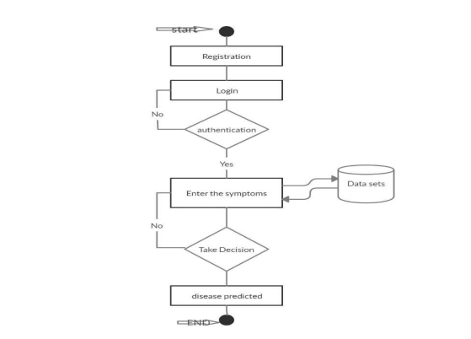

**Fig 8: State Chart diagram**

**3.7 COLLABORATION DIAGRAM**

A collaboration diagram, also known as a communication diagram, is an illustration of the relationships and interactions among software objects in the Unified Modelling Language (UML). These diagrams can be used to portray the dynamic behaviour of a particular usecase and define the role of each object. Here this diagram shows how all the models are connected to show the correct result starting from user, where he opens the system then using the system he does registration and that registration data is saved into file system and then using that data user logs in to the system and then he provides all the necessary information in order to get the accurate result, then system evaluates the user entered information and finally gives the correct result.

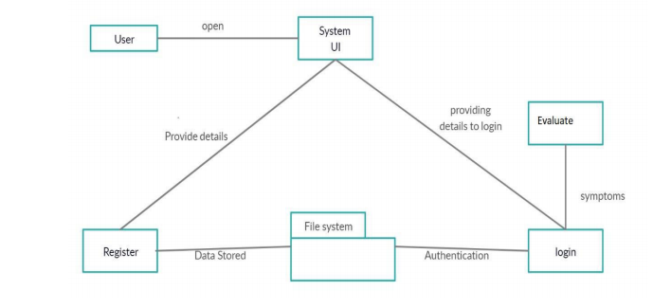

**Fig 9: Collaboration diagram**

**3.8 DEPLOYMENT DIAGRAM**

A deployment diagram shows the configuration of run time processing nodes and the components that live on them. Deployment diagrams is a kind of structure diagram used in modelling the physical aspects of an object-oriented system. Here the deployment diagram shows the final stage of the project and it also shows how the model looks after doing all the processes and deploying in the machine. Starting from the system, how it processes the user entered information and then comparing that information with the help of datasets, then training and testing that data using the algorithms such as KNN, naïve Bayes, random forest. Then finally processing all that data and information the system gives the desired result in the interface.

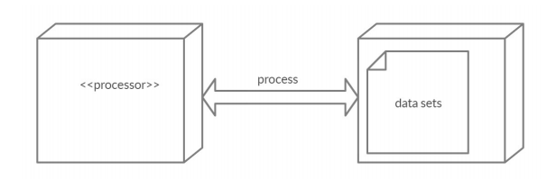

**Fig 10: Deployment diagram**

**3.9 SYSTEM ARCHITECTURE DIAGRAM**

Heart disease prediction using machine learning predicts the presence of the disease for the user based on various test report values given by the user. The architecture of the system disease prediction using machine learning consist of various datasets through which we will compare the symptoms of the user and predicts it, then the datasets are transformed into the smaller sets and from there it gets classified based on the classification algorithms later on the classified data is then processed into the machine learning technologies through which the data gets processed and goes in to the disease prediction model using all the inputs from the user . Then after the user enters the above information and overall processed data combines and compares in the prediction model of the system and finally predicts the presence of heart disease. An architecture diagram is a graphical representation of a set of concepts that are part of an architecture, including their principles, elements and components. The diagram explains about the system software in perception of overview of the system.

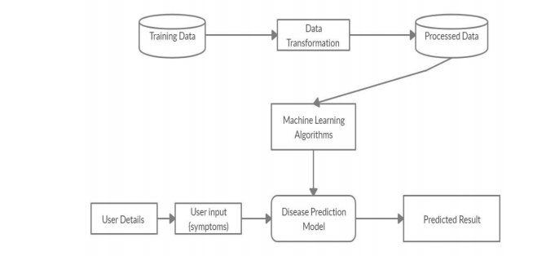

**Fig 11: System architecture diagram**

**CHAPTER 4**

**IMPLEMENTATION**

The system Heart disease Prediction using Machine Learning is developed to overcome general heart disease in earlier stages as we all know in competitive environment of economic development the mankind has involved so much that they are not concerned about health.According to research there are 40% peoples how ignores about general disease which leads to harmful disease later. The System " Heart disease Prediction using Machine Learning" is implemented using python completely. Here first the user needs to register into the system in order to use the prediction, user needs to register with username password. All these values are stored into the file system respectively, then the user has the option to move forward or leave, then the user needs to login to the system using the username and password which he/she provided during the time of registration. If he/she enters incorrect username and correct password then the error message will prompt stating incorrect username and if he/she enters incorrect password and correct username then the error message will prompt stating incorrect password, so both username and password is necessary in order to login to the system. After logging in the user needs the name and needs to select the symptoms from the given drop-down menu, for more accurate results the user needs to enter all the given symptoms, then the system will provide the accurate result. This prediction is basically done with the help of 3 algorithms of machine learning such as Decision Tree, Random Forest and KNN.When user enters all the symptoms then he needs to press the button the predicted result is shown on screen ,user needs to be satisfied with his predicted result.

The project is designed user friendly and also secure to use ever user requires a authentication to enter into the system after which it provides the result based on the user input let me explain the complete implementation and working of project step wise below

* Once a user opens the system to login, the user needs to register by clicking on the register/signup button.After which user needs to provide some basic details of signup and then the details of user are saved in system.Then user needs to login to have a checkup of his/her health.When user tries to login if he provides wrong user name the system will provide a prompt message stating that the user is not found.And if user tries to enter the wrong password the system will prompt stating that password is incorrect hence the user needs to enter the correct user id and password to get in to the system.
* After a user enters the system, the user has to provide the diagnosis test values , based on which we have several algorithms which predict the disease and also display the percentage of accuracy.The user needs to enter all the columns of the diagnosis test values to get the accurate result.
* Data collection and dataset preparation This will involve collection of medical information from various sources like hospitals, then pre-processing is applied to the dataset which will remove all the unnecessary data and extract important features from data.Training and experimentation on datasets The Disease Prediction model will be trained on the dataset of diseases to do the prediction accurately and produce Confusion matrix. In this project 3 different algorithms were used are-
  + Decision Tree Algorithm
  + Random Forest Algorithm
  + KNN Algorithm
* The working and basic explanation of those 3 algorithms Random Forest, Decision Tree and Naive Bayes is given below.

**4.1 DECISION TREE ALGORITHM**

* Decision tree induction is the learning of decision trees from class-labelled training tuples.
* A decision tree is a flowchart-like tree structure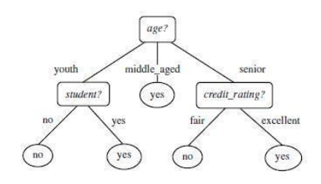

**Fig 12: Decision Tree Problem**

* Decision tree induction is a non-parametric approach for building classification models.
* Finding an optimal decision tree is an NP-complete problem.
* Techniques developed for constructing decision trees are computationally inexpensive, making it possible to construct models even when the training set size is very large.
* Decision trees, especially smaller-sized trees, are relatively easy to interpret.
* Decision trees provide an expressive representation for learning discrete-valued functions.
* Decision tree algorithms are quite robust to the presence of noise, especially when methods for avoiding overfitting.

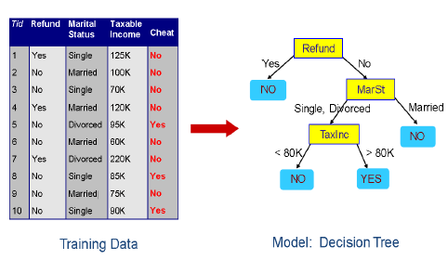

**Fig 13: Decision Tree Example**

* The presence of redundant attributes does not adversely affect the accuracy of the decision tree.
* The construction of decision tree classifiers does not require any domain knowledge or parameter setting, and therefore is appropriate for exploratory knowledge discovery. Decision trees can handle high dimensional data.
* Their representation of acquired knowledge in tree form is intuitive and generally easy to assimilate by humans.
* The learning and classification steps of decision tree induction are simple and fast.
* In general, decision tree classifiers have good accuracy.
* Decision tree induction algorithms have been used for classification in many application areas, such as medicine, manufacturing and production, financial analysis, astronomy, and molecular biology.

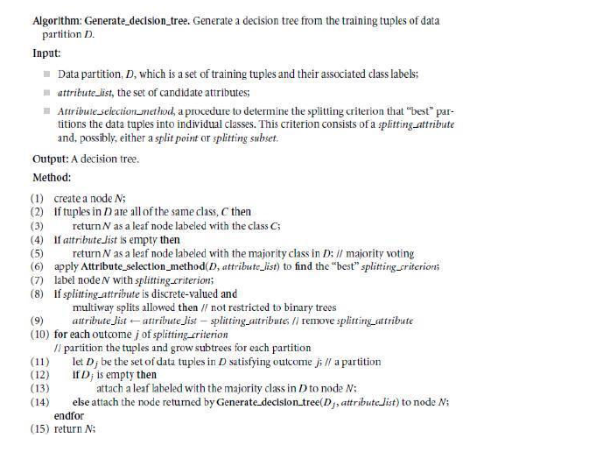

**Fig 14: Decision Tree Algorithm**

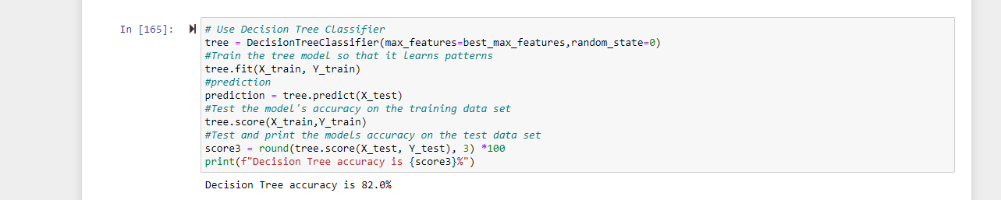

**Fig 15: Decision Tree Code snippet**

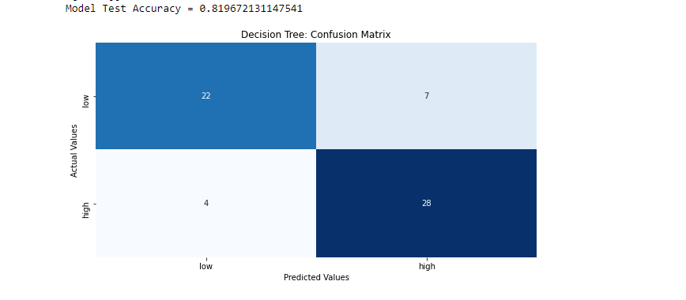

**Fig 16: Decision Tree Confusion Matrix**

**4.2 RANDOM FOREST ALGORITHM**

* It is an ensemble classifier using many decision trees models; it can be used for regression as well as classification.
* Accuracy and variable importance information can be provided with the results.
* A random forest is the classifier consisting of a collection of tree structured classifiers k,where the k is independently, identically distributed random trees and each random tree consists of the unit of vote for classification of input.
* Random forest uses the Gini index for the classification and determining the final class in each tree.
* The final class of each tree is aggregated and voted by the weighted values to construct the final classifier.
* The working of random forest is , a forest seed is chosen which is pulled out at random, a collection of samples from the training datasets while maintaining the class distribution.

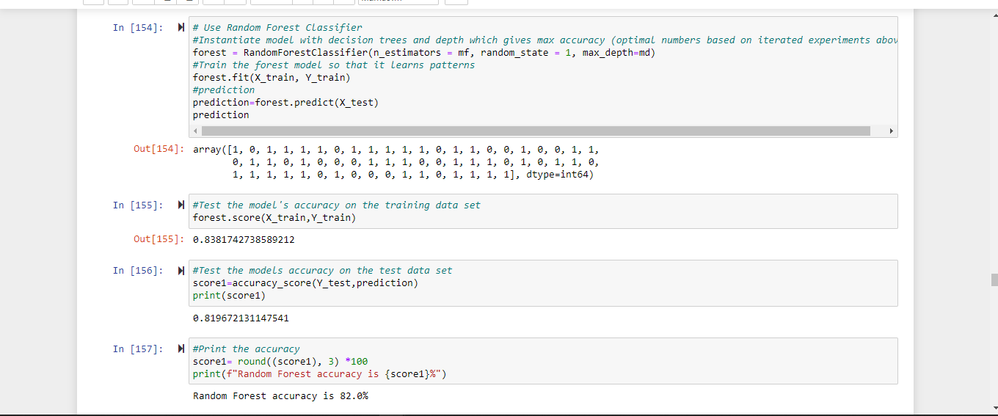

**Fig 17: Random Forest Code Snippet**

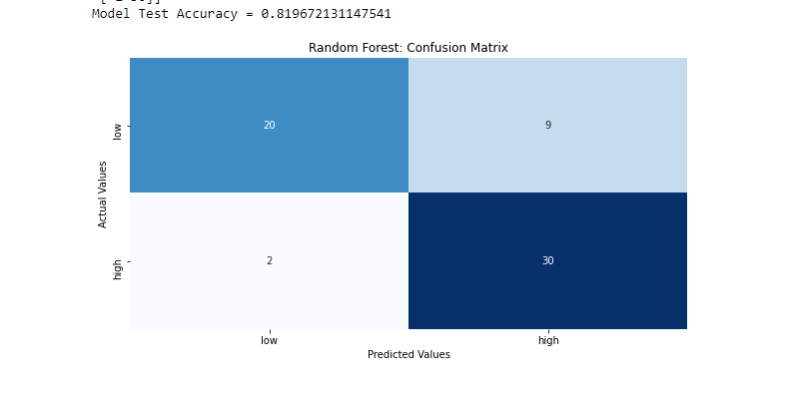

**Fig 18: Random Forest Confusion Matrix**

**4.3 K-NEAREST NEIGHBOUR ALGORITHM**

* K-Nearest Neighbour is one of the simplest Machine Learning algorithms based on Supervised Learning technique.
* The K-NN algorithm assumes the similarity between the new case/data and available cases and puts the new case into the category that is most similar to the available categories.
* K-NN algorithm stores all the available data and classifies a new data point based on the similarity. This means when new data appears then it can be easily classified into a well suited category by using K- NN algorithm.
* The K-NN algorithm can be used for Regression as well as for Classification but mostly it is used for the Classification problems.
* K-NN is a **non-parametric algorithm**, which means it does not make any assumption on underlying data.
* It is also called a **lazy learner algorithm** because it does not learn from the training set immediately instead it stores the dataset and at the time of classification, it performs an action on the dataset.
* The KNN algorithm at the training phase just stores the dataset and when it gets new data, then it classifies that data into a category that is much similar to the new data.

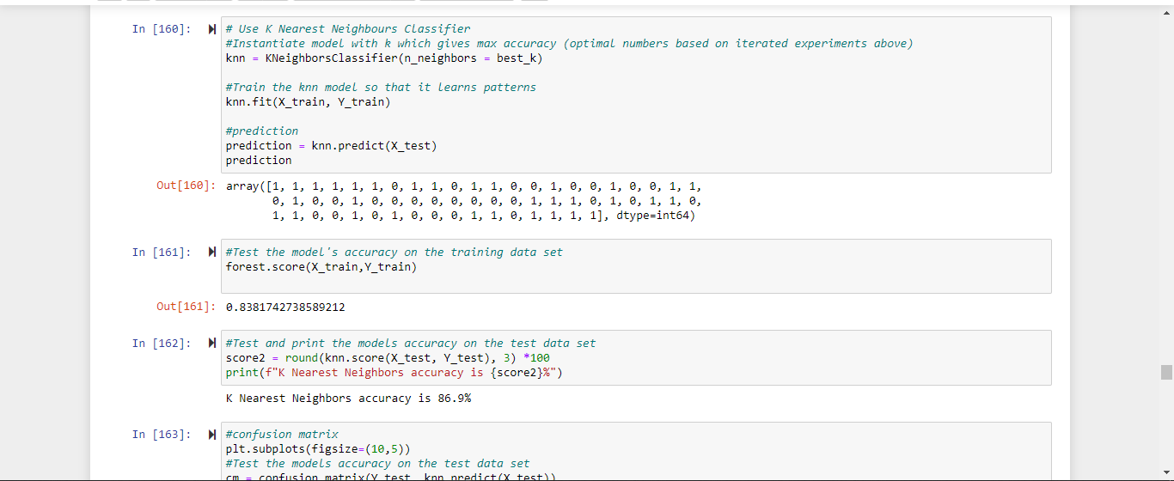

**Fig 19: KNN Code Snippet**

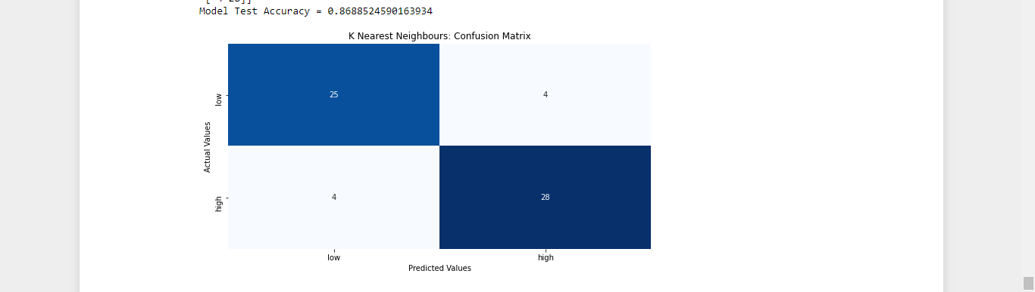

**Fig 20: KNN Confusion Matrix**

**4.4 Description of Modules**

The model consists of 4 modules which include:

* The “Home” Page
* The home page includes two options for the user. The user can either REGISTER (if you are a new user) or LOGIN(if you already are a registered user).

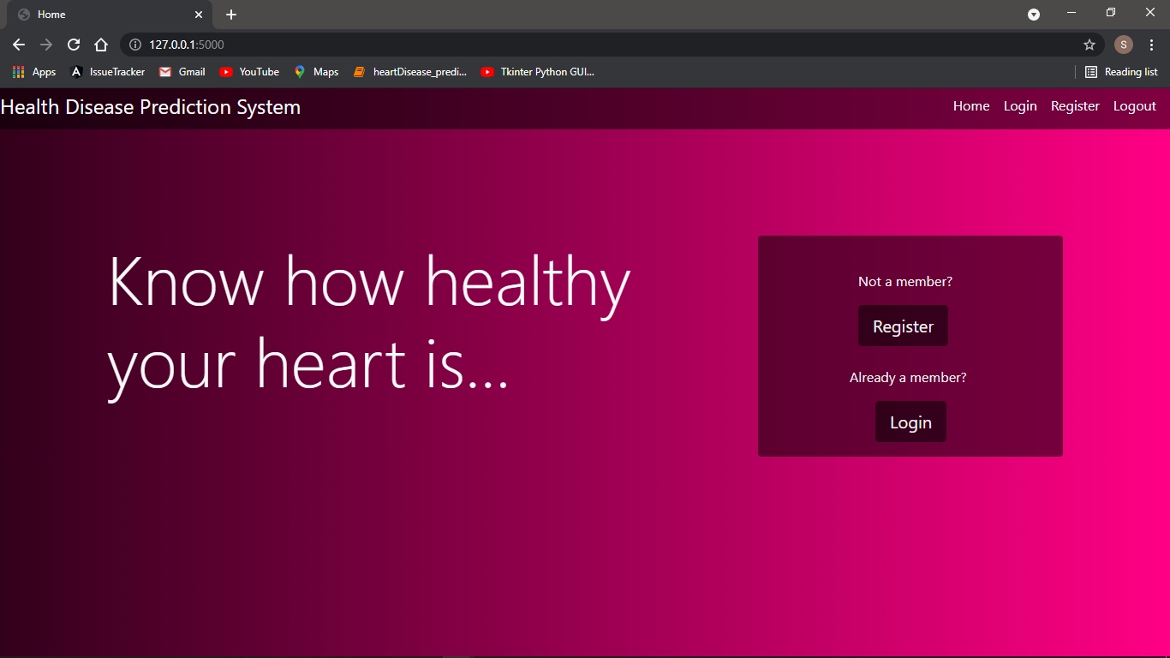

**Fig 21: The “Home” page**

* The “Register” Page
  + Once the user selects the “Register” option in the home page , it prompts the user to the Register Page. Here the user is required to enter their details which are stored into the database. Once registered he can either login or go back to the Home Page.

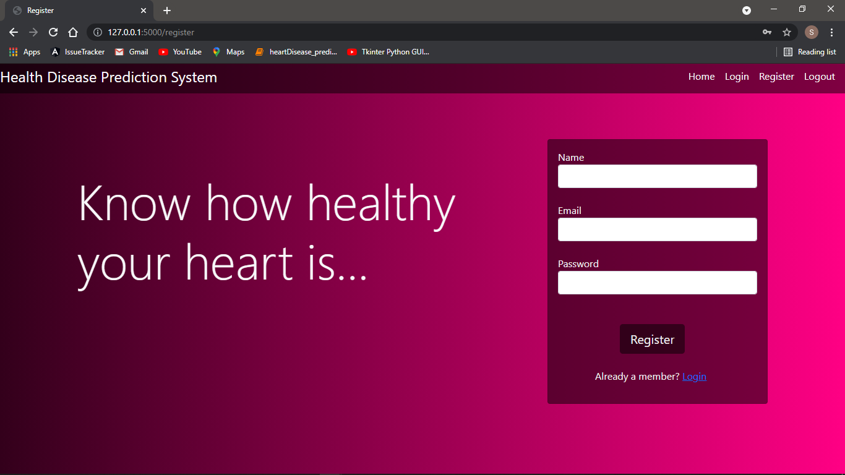

**Fig 22: The “Register” page**

* The “Login” Page
* A registered user when selects the “login” option in the home page, it prompts the user to the Login Page. Here the user is required to enter their credentials which are verified against the data in the database. If the information is verified , the user  is directed to the “Enter the diagnosis test values” page else he is asked to recheck his information.

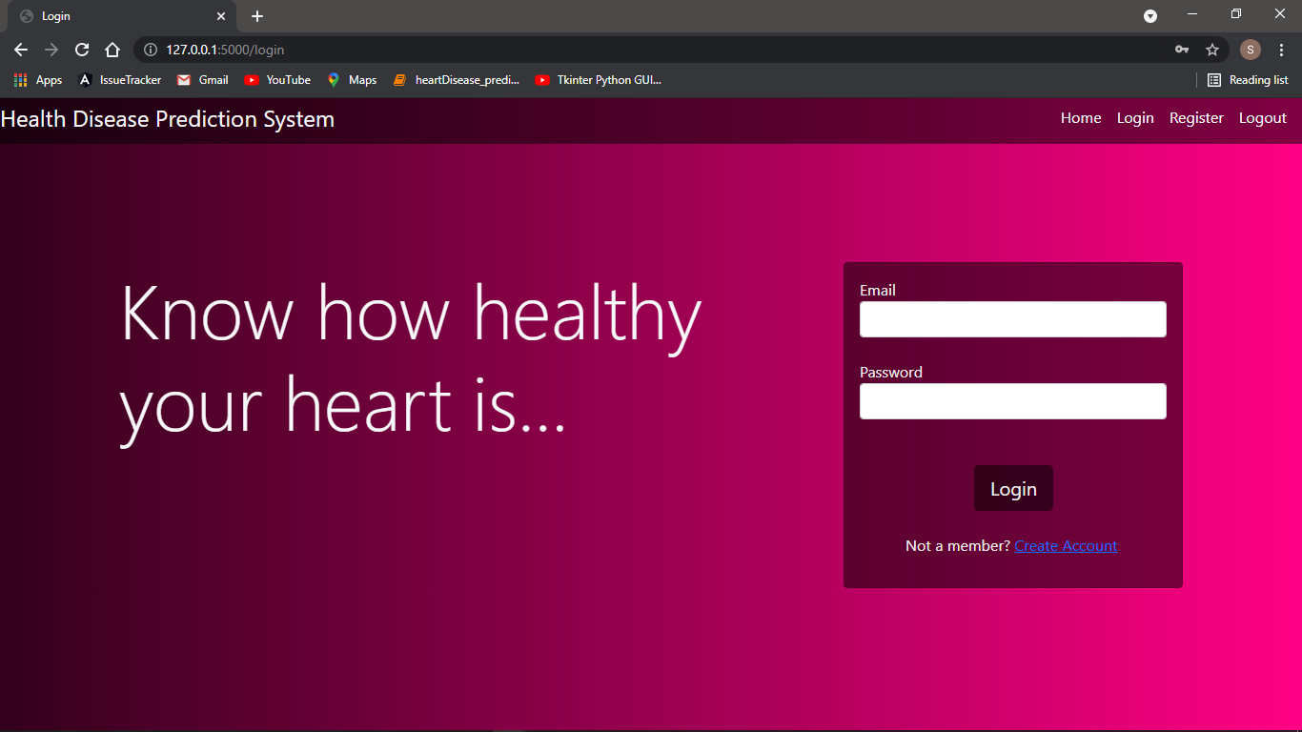

**Fig 23: The “Login” page**

* “Enter the Diagnosis test values” Page
* The user is required to enter the test values which are taken by the system.

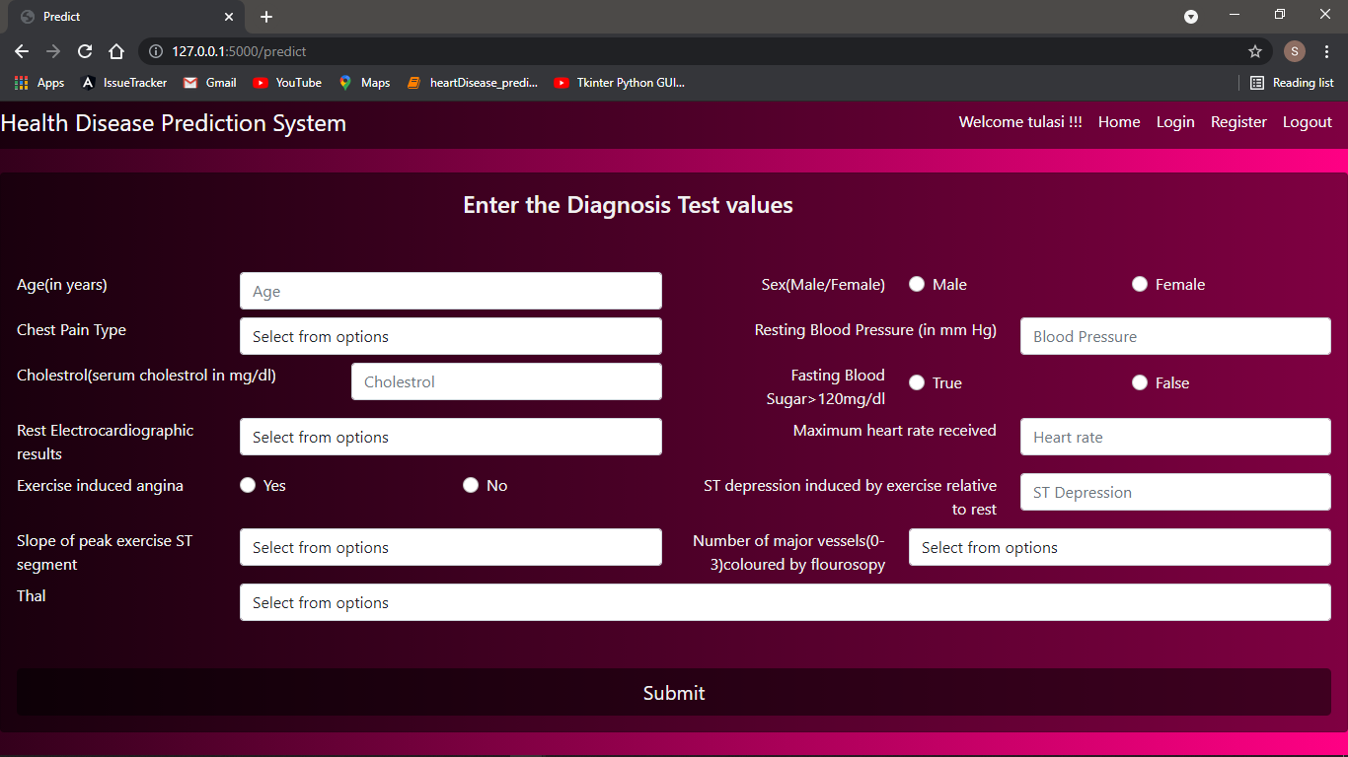

**Fig 24: “Enter the diagnosis test values” page**

* ‘’Result page’’

The predicted result is displayed here.

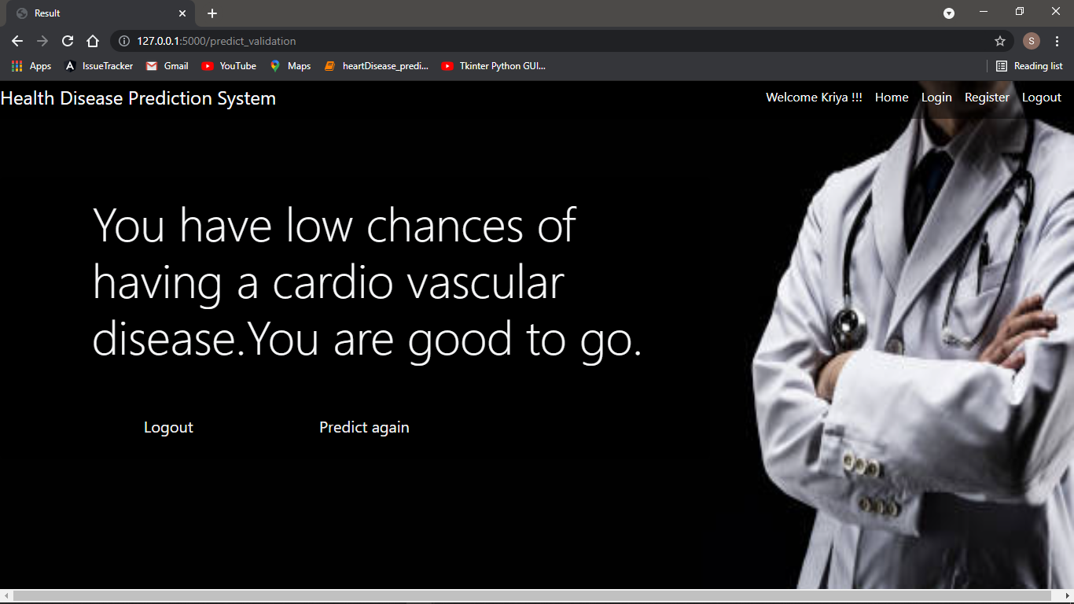

**Fig 25: The “Result” page**

**4.5 IMPORTANT CODE SNIPPETS**

**Code snippet for registration**

def register_validation():

name = request.form.get("nameR")

email = request.form.get("emailR")

password = request.form.get("passwordR")

specialsym = ['$', '@', '#', '%']

val = True

if len(password) < 6:

flash('Length of password should be at least 6', 'info')

return render_template("register.html")

if len(password) > 20:

flash('Length of password should be not be greater than 8')

return render_template("register.html")

if not any(char.isdigit() for char in password):

flash('Password should have at least one numeral')

return render_template("register.html")

if not any(char.isupper() for char in password):

flash('Password should have at least one uppercase letter')

return render_template("register.html")

if not any(char.islower() for char in password):

flash('Password should have at least one lowercase letter')

return render_template("register.html")

if not any(char in specialsym for char in password):

flash('Password should have at least one of the symbols $@#')

return render_template("register.html")

conn = sqlite3.connect("users.db")

c = conn.cursor()

c.execute('''CREATE TABLE IF NOT EXISTS USER(name text, email text,password text)''')

conn.commit()

sql = """INSERT INTO USER (NAME,EMAIL,PASSWORD) VALUES(?,?,?)"""

cursor = conn.cursor()

cursor.execute(sql, (name, email, password))

conn.commit()

print("Records Created")

table = conn.execute("SELECT * FROM USER")

for row in table:

print(row[0]+" "+row[1]+"\n")

conn.close()

flash('Registration successful you can login with your credentials', 'info')

return render_template("login.html")

**Code snippet for login**

def login_validation():

email = request.form.get("email")

password = request.form.get("password")

flag = 1

conn = sqlite3.connect("users.db")

c = conn.cursor()

c.execute('''CREATE TABLE IF NOT EXISTS USER(name text, email text,password text)''')

conn.commit()

table = conn.execute("SELECT * FROM USER")

for row in table:

print(email + " " + password+" "+row[1]+" "+row[2])

if email == row[1] and password == row[2]:

uname = row[0]

flag = 0

if flag == 0:

print(email+" "+password)

session['name'] = uname

print(session['name'])

return redirect(url_for("predict"))

else:

flash("Please recheck your credentials")

return render_template("login.html")

**Code snippet for prediction**

def predict_validation():

attr1 = request.form.get("age")

if request.form.get("sex") == "female":

attr2 = "0"

else:

attr2 = "1"

attr3 = request.form.get("chestpain")

attr4 = request.form.get("bp")

attr5 = request.form.get("cho")

if request.form.get("sugar") == "false":

attr6 = "0"

else:

attr6 = "1"

attr7 = request.form.get("ecg")

attr8 = request.form.get("hr")

if request.form.get("angina") == "no":

attr9 = "0"

else:

attr9 = "1"

attr10 = request.form.get("ST")

attr11 = request.form.get("slope")

attr12 = request.form.get("vessels")

attr13 = request.form.get("thal")

attr = [[int(attr1), int(attr2), int(attr3), int(attr4), int(attr5), int(attr6), int(attr7), int(attr8), int(attr9), float(attr10), int(attr11), int(attr12), int(attr13)]]

our_model = pickle.load(open('heart.pkl', 'rb'))

prediction = our_model.predict(attr)[0]

if prediction == 1:

flash("You have high chances of having a cardiovascular disease.Please consult a doctor.")

return render_template("result.html")

else:

flash("You have low chances of having a cardiovascular disease.You are good to go.")

return render_template("result.html")

**Code snippet for logout**

def logout():

if 'name' in session:

session.pop('name', None)

return redirect(url_for("home"))

else:

flash("Login in inorder to logout")

return redirect(url_for("login"))

**4.6 TOOLS**

The various tools used for the project are listed below along with their descriptions.

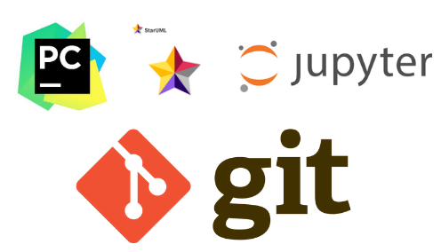

**Fig 26: Logos of various tools used**

* **PYCHARM**

PyCharm is a dedicated Python Integrated Development Environment (IDE) providing a wide range of essential tools for Python developers, tightly integrated to create a convenient environment for productive Python, web, and data science development.

* **GIT**

Git is a free and open source distributed version control system designed to handle everything from small to very large projects with speed and efficiency. Git is easy to learn and has a tiny footprint with lightning fast performance.

* **JUPYTER**

Jupyter is a free, open-source, interactive web tool known as a computational notebook, which researchers can use to combine software code, computational output, explanatory text and multimedia resources in a single document.

* **STARUML**

StarUML is a tool to create class diagrams and other types of diagrams in the Unified Modeling Language (UML). This module is a short tutorial on using StarUML to create class diagrams in Java. StarUML (SU) is a tool to create UML class diagrams and automatically generate Java "stub code"

**4.8 TECHNOLOGIES USED**

The various technologies used are given below

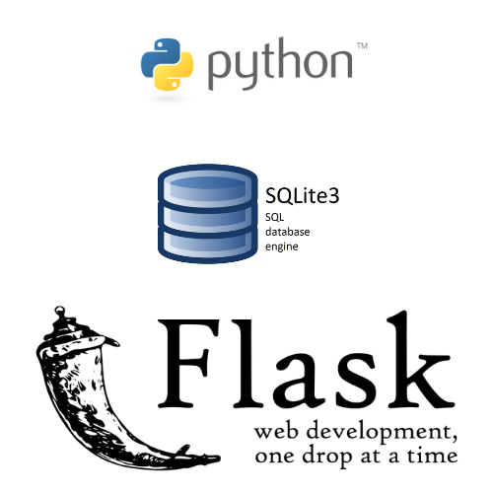

**Fig 27: Various technologies used**

* **Python**

(Various libraries used are NumPy,Pandas,Sklearn,Matplotlib,Seaborn)

**Pandas**:Pandas is a python library used for data analysis.It is used to create a dataframe that is a 2D data structure similar to excel sheet.

**Numpy**:Numpy is a python library used to handle multidimensional arrays.

**Matplotlib**:Matplotlib is a 2D plotting library for creating plots and graphs.

**Seaborn**:Seaborn is a Python data visualization library based on matplotlib.It provides a high-level interface for drawing attractive and informative statistical graphics.

**Sklearn**:Scikit-learn is the most useful library for machine learning in Python. The sklearn library contains a lot of efficient tools for machine learning and statistical modeling including classification, regression, clustering and dimensionality reduction.We have used RandomForestClassifier, DecisionTreeClassifier and KNeighbourClassifier.

* **SQLite3**

SQLite3 is a very easy to use database engine. It is self-contained, serverless, zero-configuration and transactional. The Python Standard Library includes a module called "sqlite3" intended for working with this database.

* **Flask**

Flask is an API of Python that allows us to build up web-applications.Flask's framework is easier to learn because it has less base code to implement a simple web-Application.

**CHAPTER 5**

**TESTING**

The project is tested upon various test cases whose details and corresponding results are described in this chapter:

**Case 1 : Invalid Registration Details**

If a user tries to register with an already registered email or enters an invalid password i.e. with a length less than 6 characters or greater than 20 characters or if the password does not have any of the following (number,uppercase alphabet,lowercase alphabet,symbol) an alert is displayed which notifies the user.

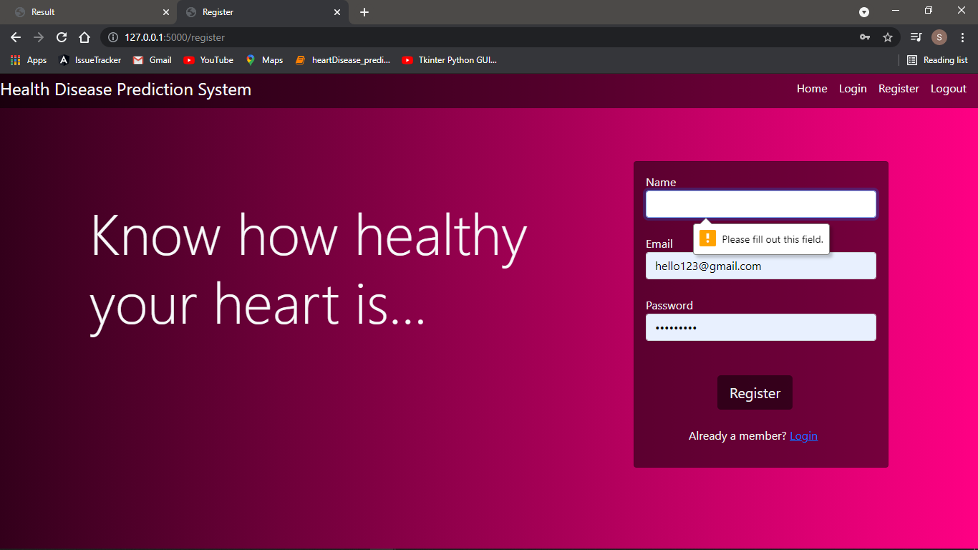

**Fig 28: Name field empty alert**

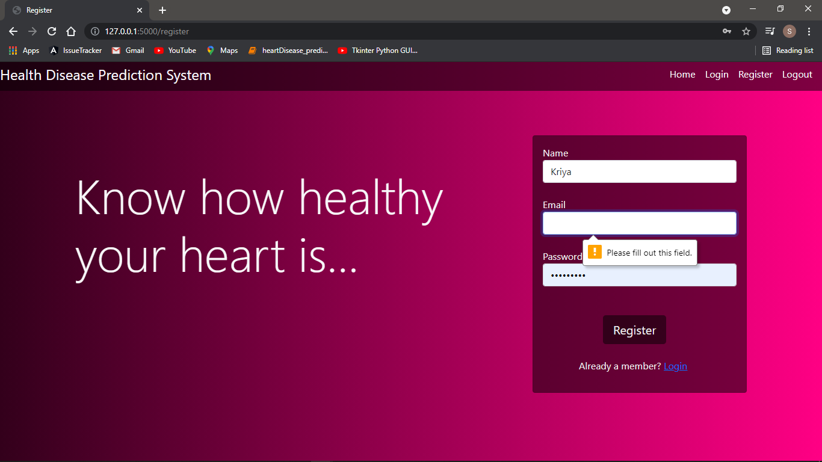

**Fig 29: email field empty alert**

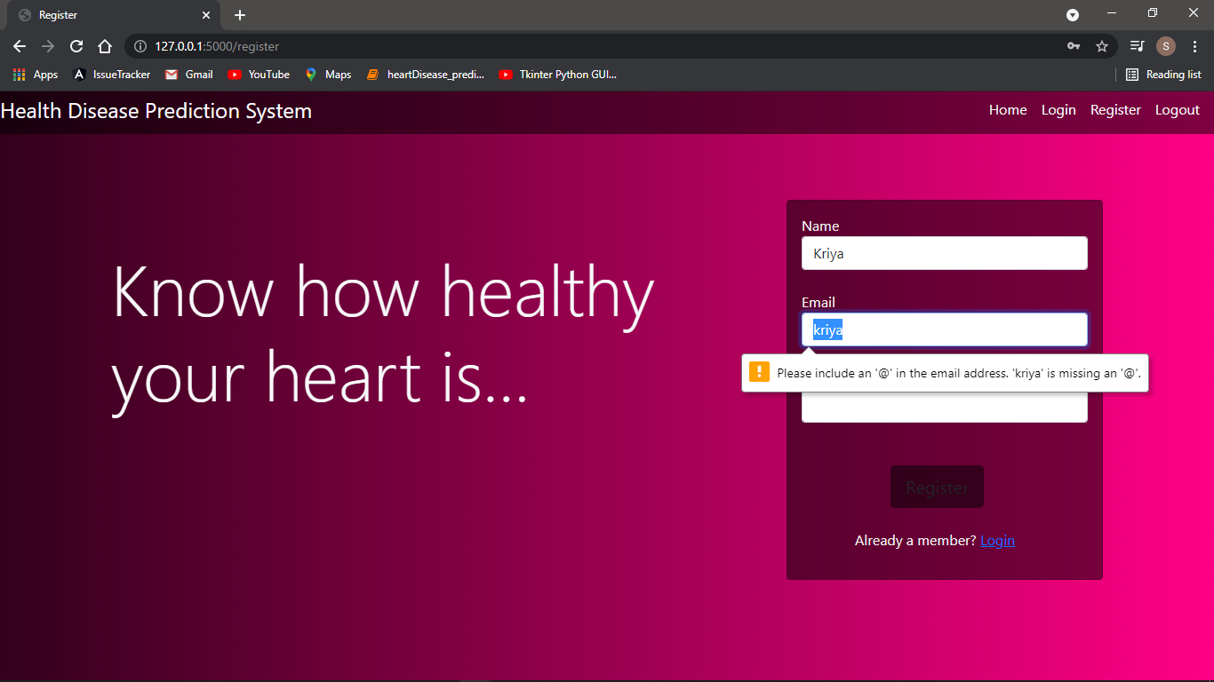

**Fig 30: email format incorrect alert**

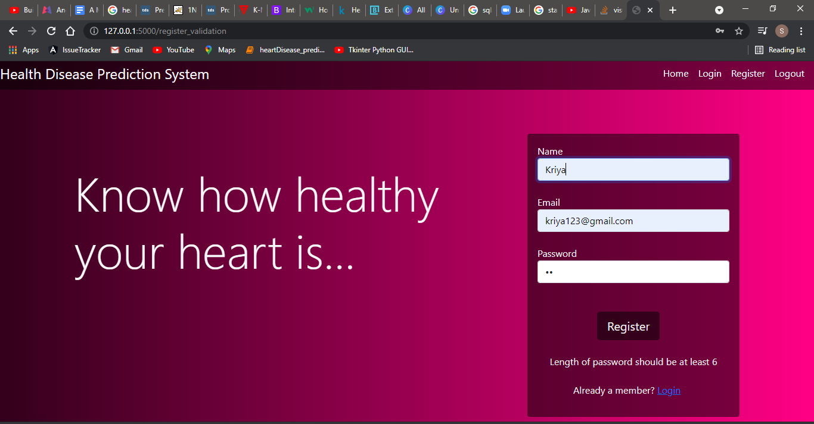

**Fig 31: Password length should be at least 6 characters alert**

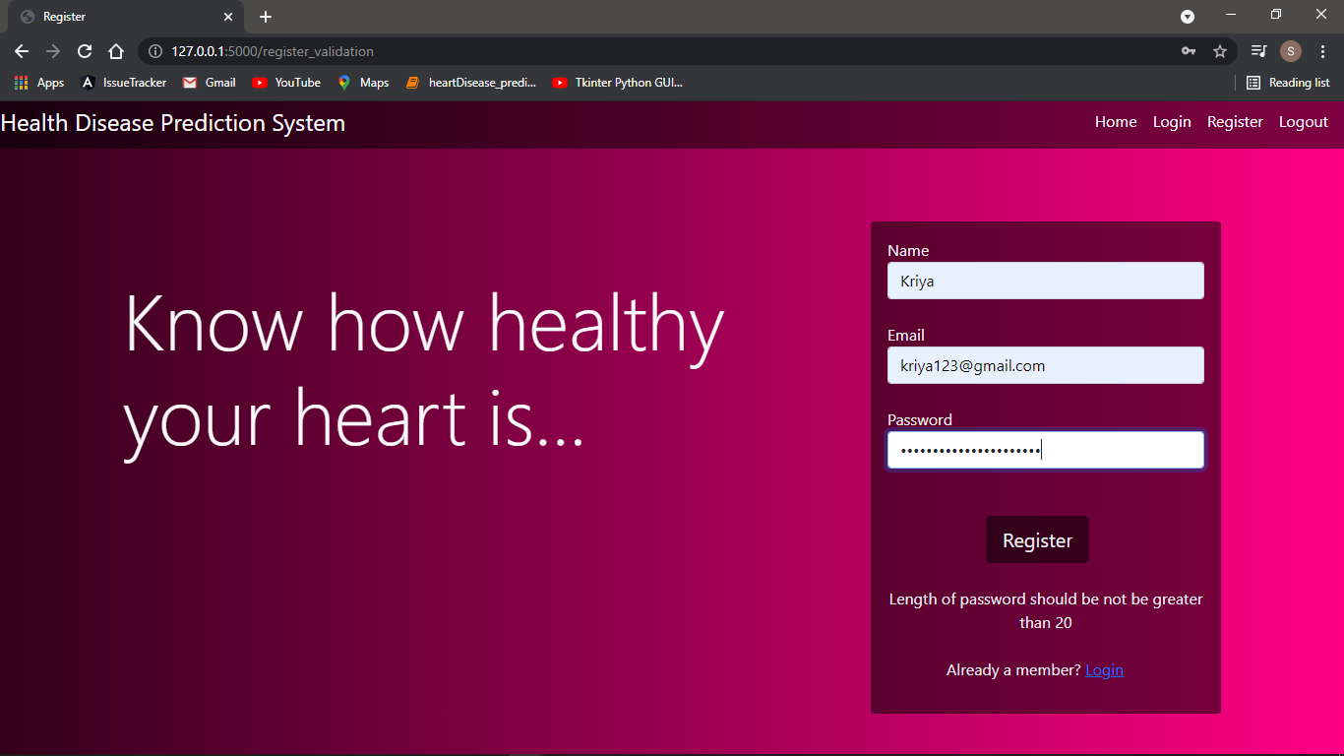

**Fig 32: Password length should not be greater than 20 alert**

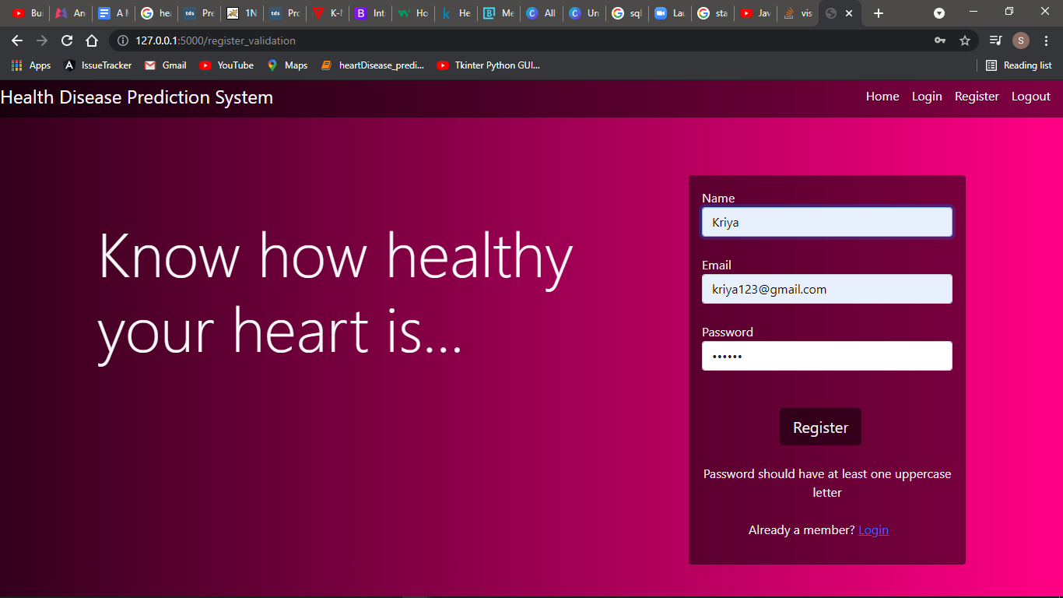

**Fig 33: Password should have at least one uppercase letter alert**

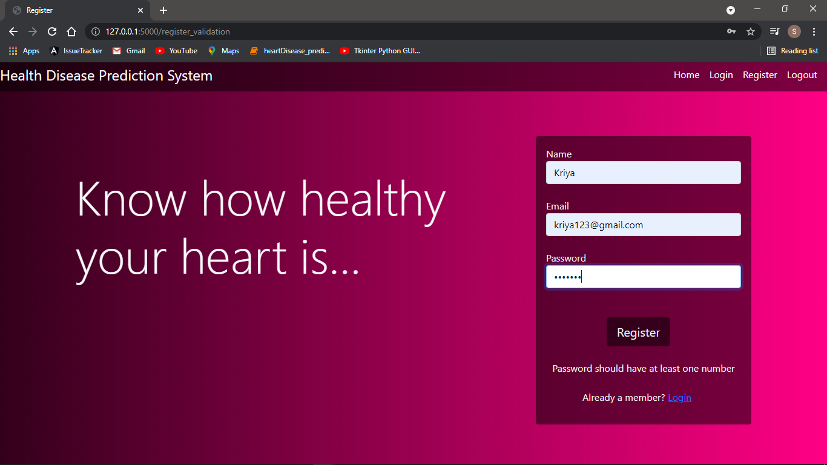

**Fig 34: Password should have at least one number alert**

.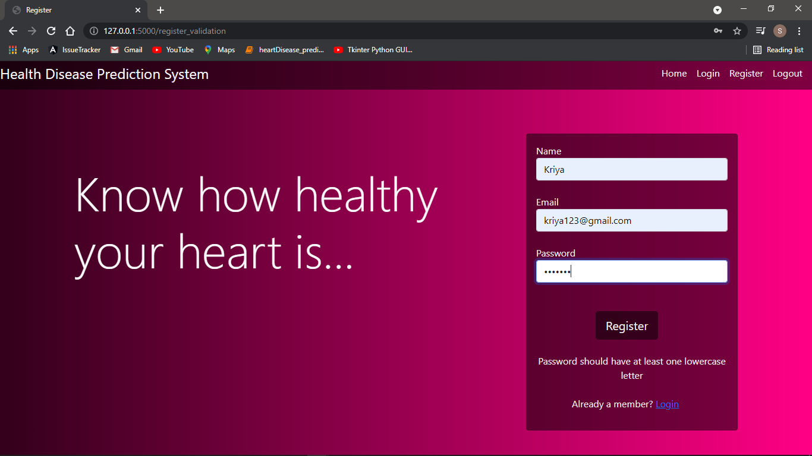

**Fig 35: Password should have at least one lowercase letter alert**

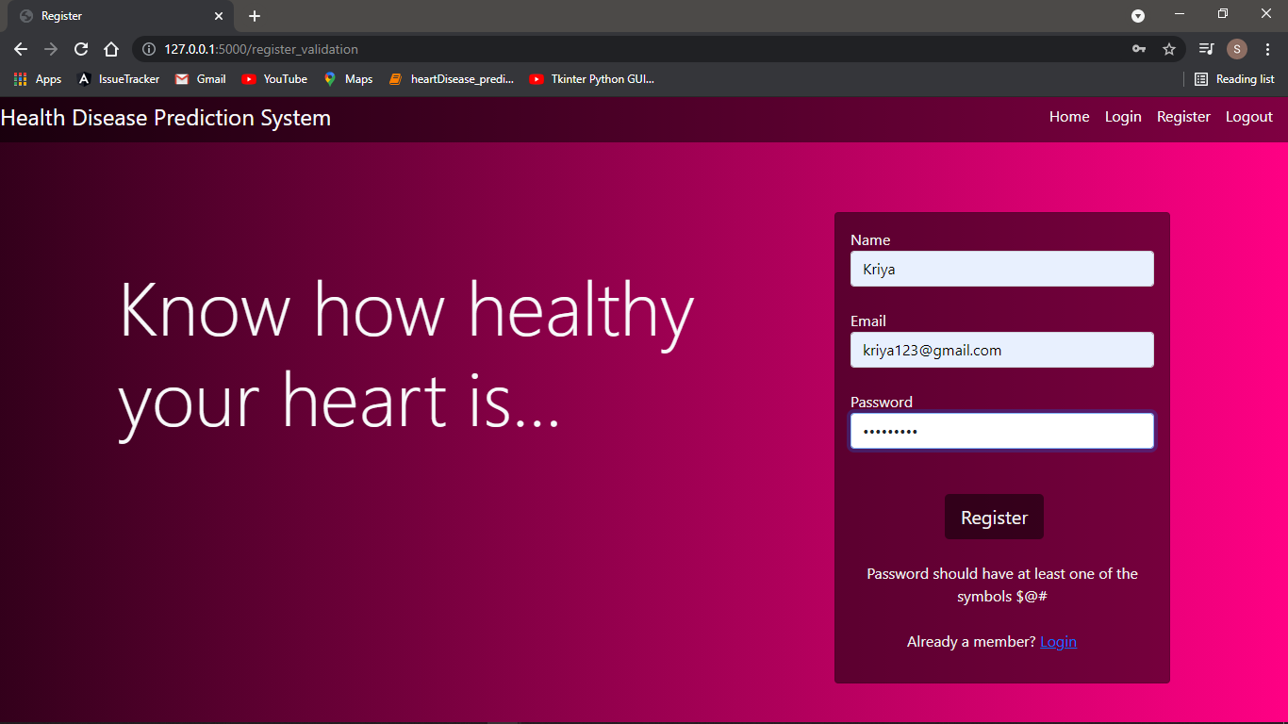

**Fig 36: Password should have at least one symbol alert**

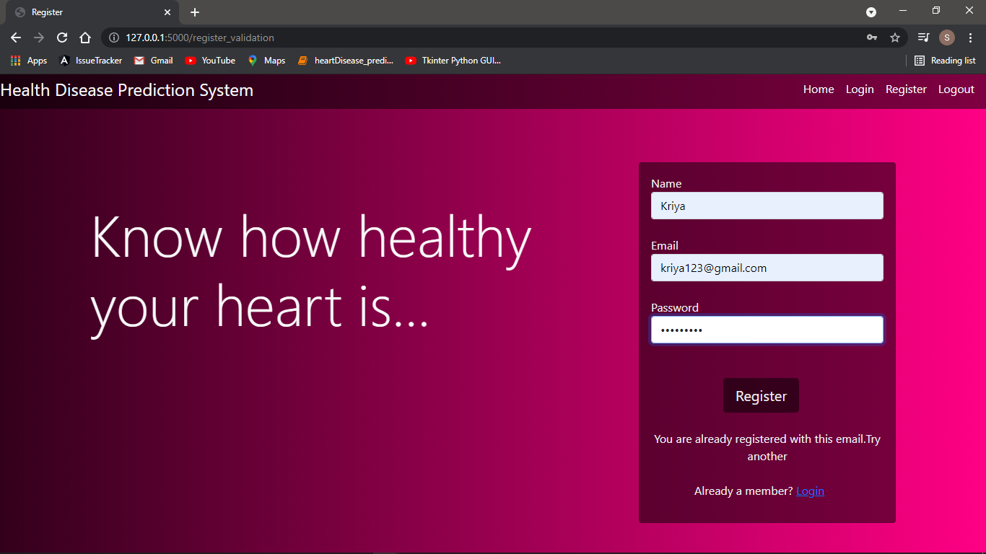

**Fig 37: Already Existing User Alert**

**Case 2 : Invalid Login Details**

If a user enters an invalid email or an invalid password, an alert is displayed which notifies the user.

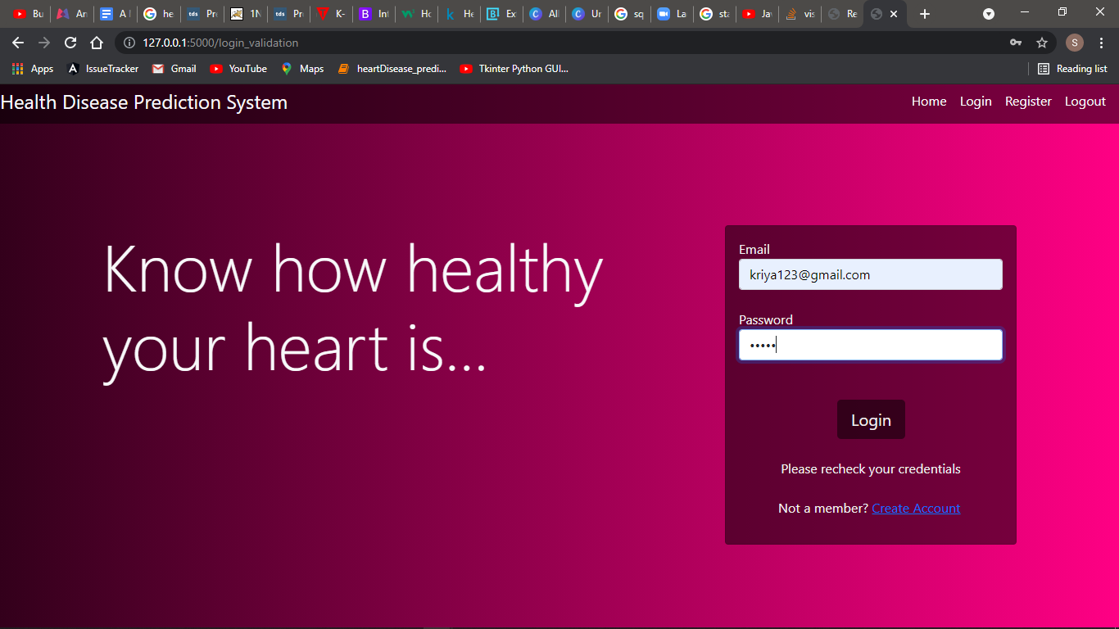

**Fig 38: Invalid credentials alert**

**Case 3:Trying to predict without logging in**

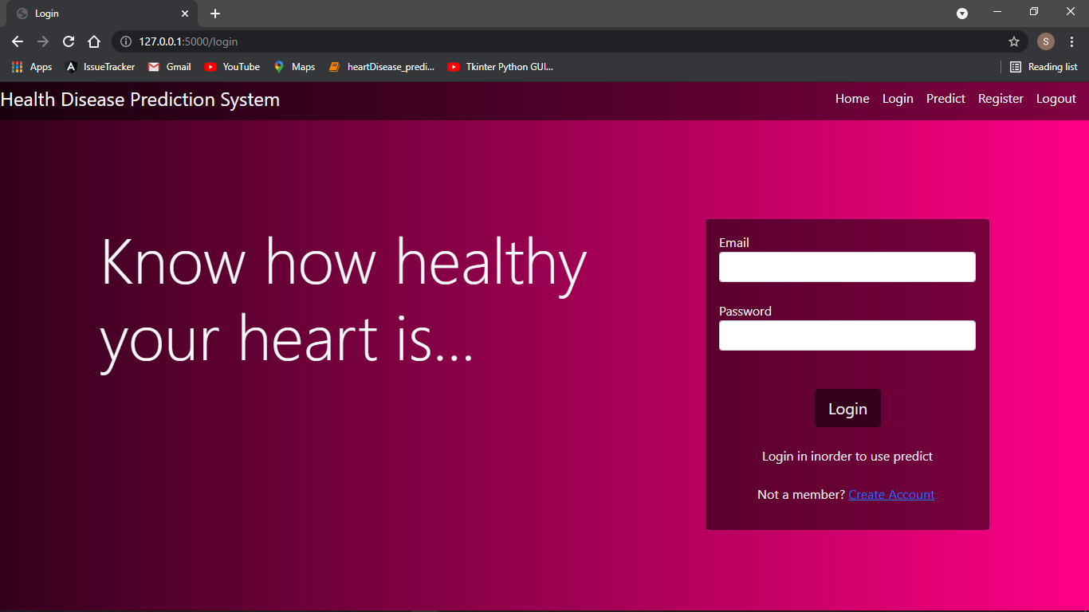

**Fig 39: Login before prediction alert**

**Case 4:Trying to logout without logging in**

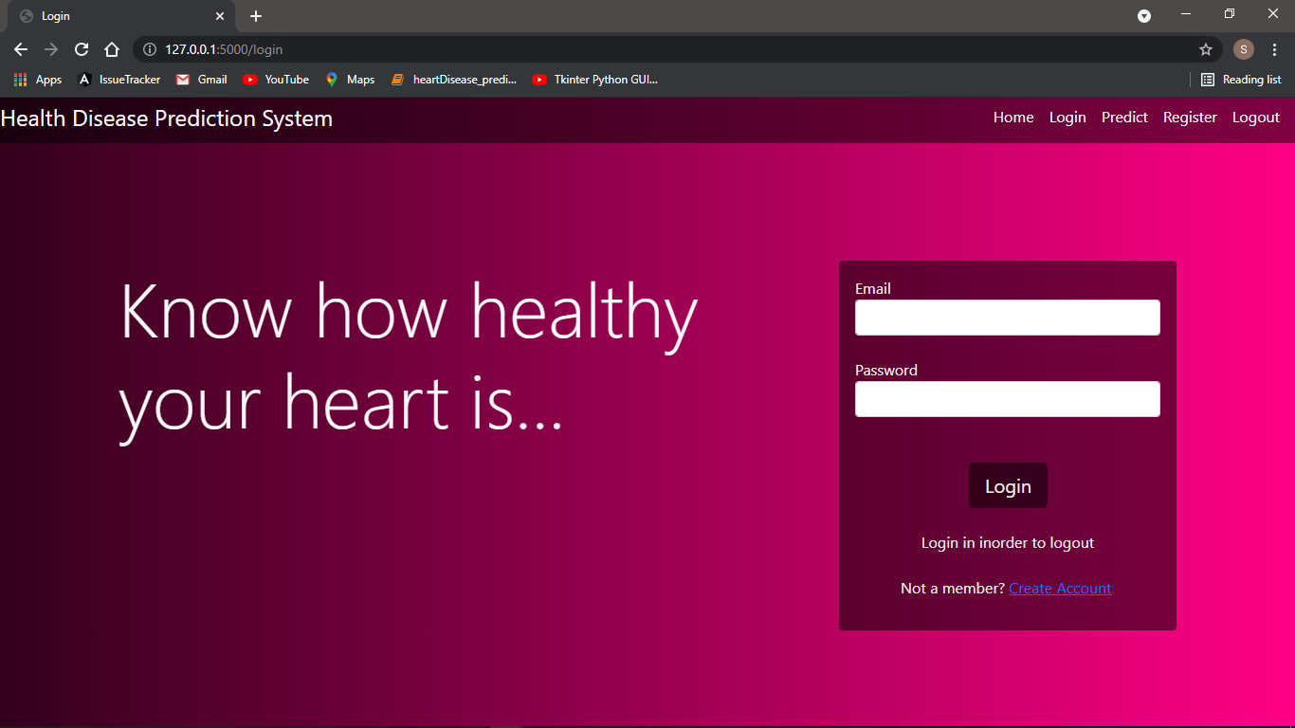

**Fig 40: Login first alert**

**Case 5:Accuracy Test**

Our model first estimates the accuracy of the 3 models built(forest,tree,knn)and then uses the model with highest accuracy to predict.



**Fig 41: Accuracies of algorithms used**

**Conclusion**

The overall aim is to define various data mining techniques useful in effective heart disease prediction( Efficient and accurate) .The data were pre-processed and then used in the model. Random Forest and Ensemble models have performed very well because they solve the problem of overfitting by employing multiple algorithms (multiple Decision Trees in case of Random Forest)prediction with a lesser number of attributes and tests is our goal.

**Future Enhancements**

* Enhance the UI of the model.
* Improve the accuracy of the model.
* Add additional features like “forgot password”,”edit details”.
* Provide information to the user so as to consult a doctor through the same interface.

**References**

[1]S. Babu et al., "Heart disease diagnosis using data mining technique," 2017 International conference of Electronics, Communication and Aerospace Technology (ICECA), 2017, pp. 750-753, doi: 10.1109/ICECA.2017.8203643.

[2]M. Kavitha, G. Gnaneswar, R. Dinesh, Y. R. Sai and R. S. Suraj, "Heart Disease Prediction using Hybrid Machine Learning Model," 2021 6th International Conference on Inventive Computation Technologies (ICICT), 2021, pp. 1329-1333, doi: 10.1109/ICICT50816.2021.9358597.

[3] Z. Dobesova, "Programming language Python for data processing," *2011 International Conference on Electrical and Control Engineering*, 2011, pp. 4866-4869, doi: 10.1109/ICECENG.2011.6057428.

[4] J. Rahmonov, "PyCharm for Productive Python Development (Guide) – Real Python", *Realpython.com*, 2021. [Online]. Available: https://realpython.com/pycharm-guide/. [Accessed: 18- May- 2021].

[5] S. Ray, "A Quick Review of Machine Learning Algorithms," 2019 International Conference on Machine Learning, Big Data, Cloud and Parallel Computing (COMITCon), 2019, pp. 35-39, doi: 10.1109/COMITCon.2019.8862451.

[6] "Python Tutorial - w3resource", *w3resource*, 2019. [Online]. Available: https://www.w3resource.com/python/python-tutorial.php. [Accessed: 10- May- 2021].

[7] "Machine Learning Tutorial - Tutorialspoint", *Tutorialspoint.com*, 2018. [Online]. Available: https://www.tutorialspoint.com/machine_learning/index.htm. [Accessed: 04- May- 2021].

**Appendix A – Abbreviations**

|  |  |
| --- | --- |
| **Abbreviation** | **Full Form** |
| **ML** | Machine Learning |
| **CAD** | Coronary artery disease |
| **KNN** | K nearest neighbour |

**Appendix B – Software Installation Procedure**

**1.Python installation**

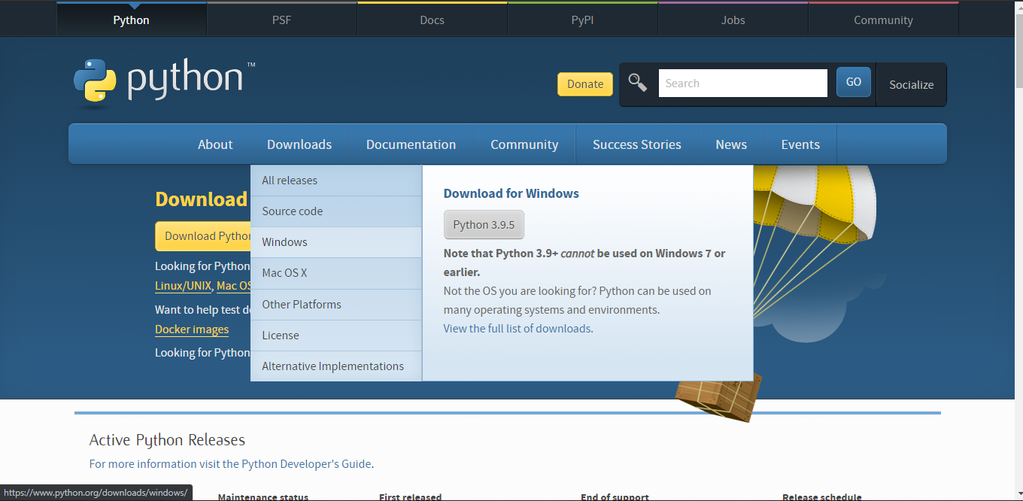

**Fig 42: Downloading Python**

**2.Pycharm Installation**

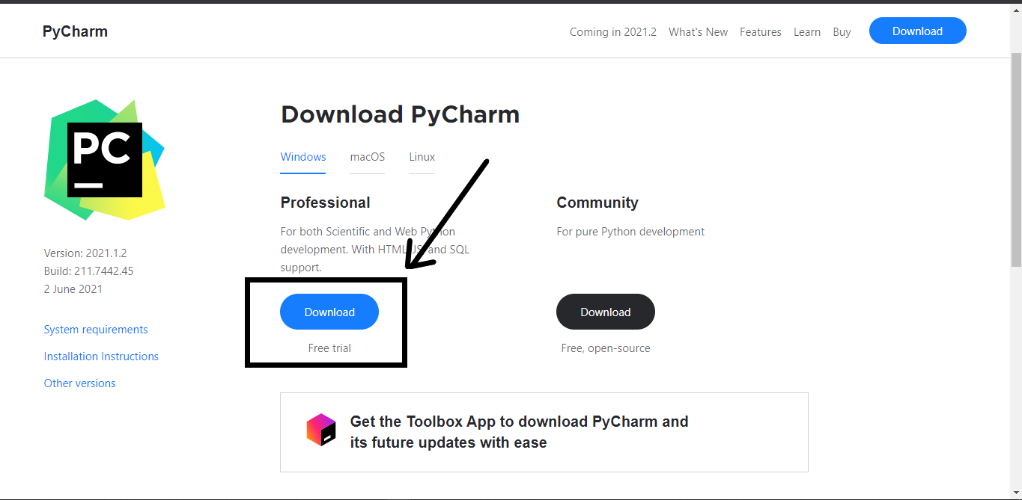

**Fig 43: Downloading Pycharm**

**3.Anaconda Download**

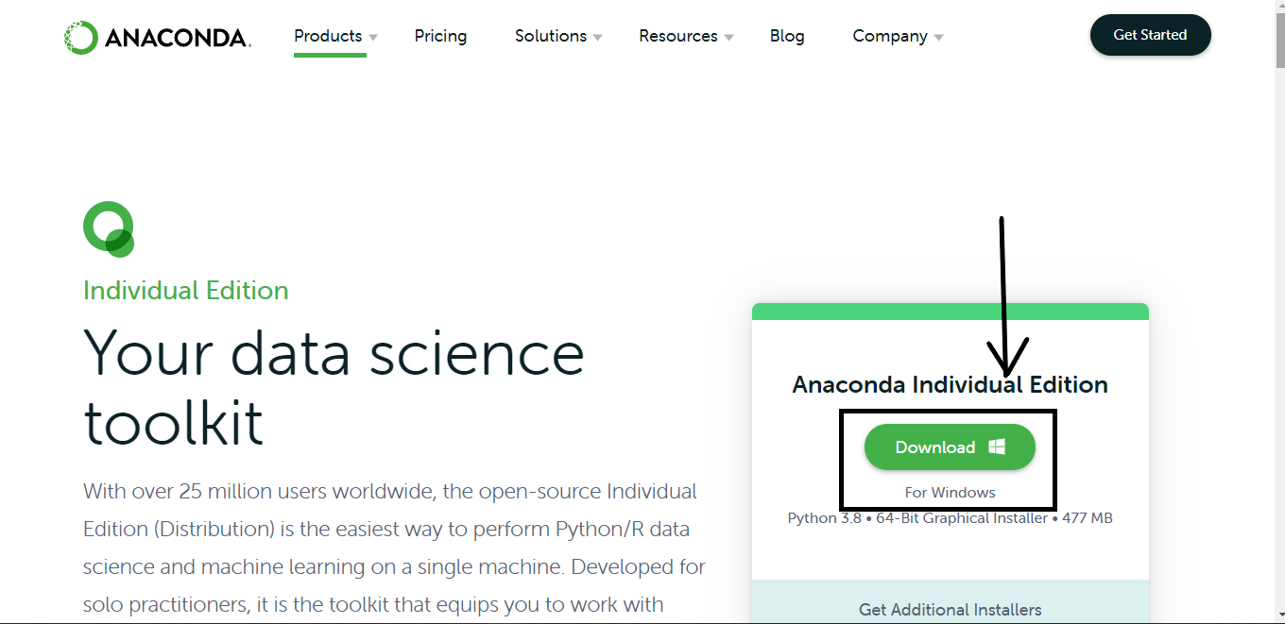

**Fig 44: Downloading Anaconda**

**Appendix C – Software Usage Process**

**1.Open command prompt and run jupyter notebook command**

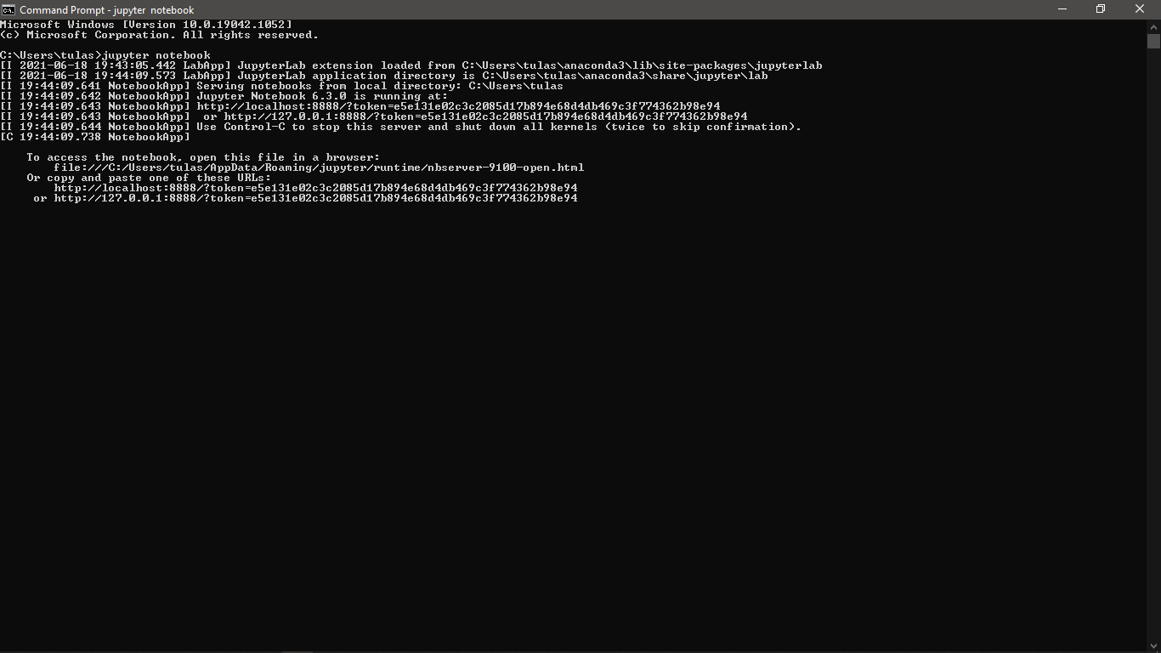

**Fig 45: jupyter notebook command**

**2.Run the project in jupyter notebook**

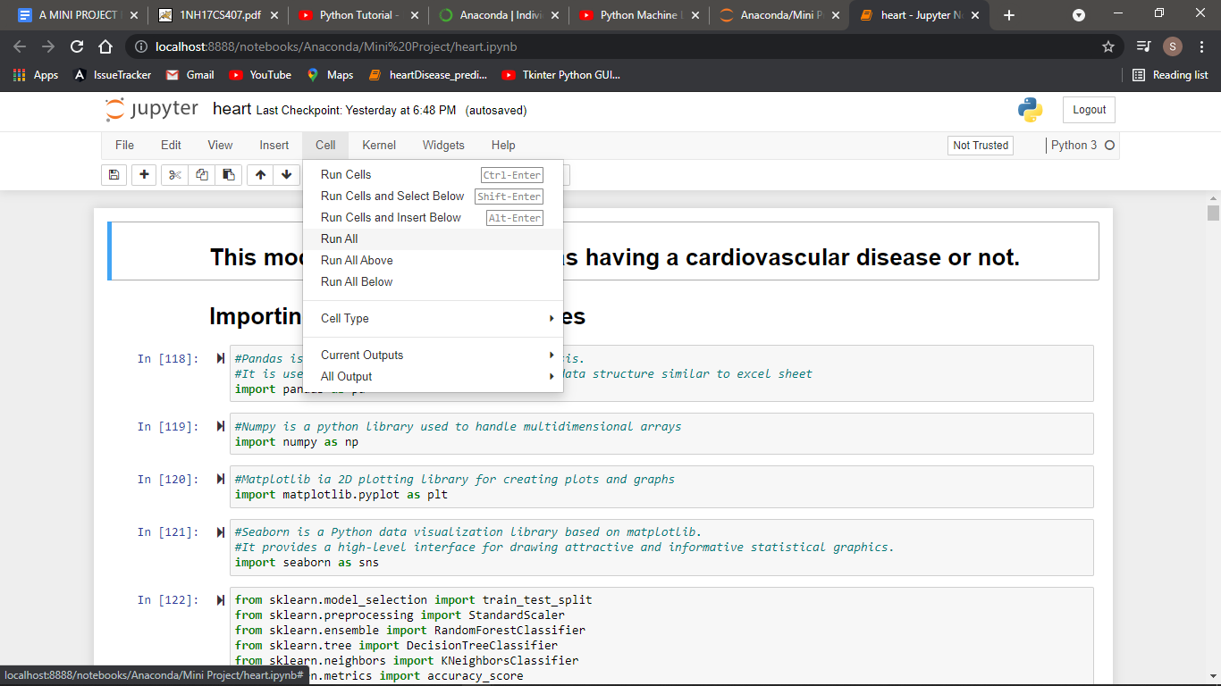

**Fig 46: Run all cells**

**3.Run flask in pycharm**

Once the model is created, run the flask in pycharm.

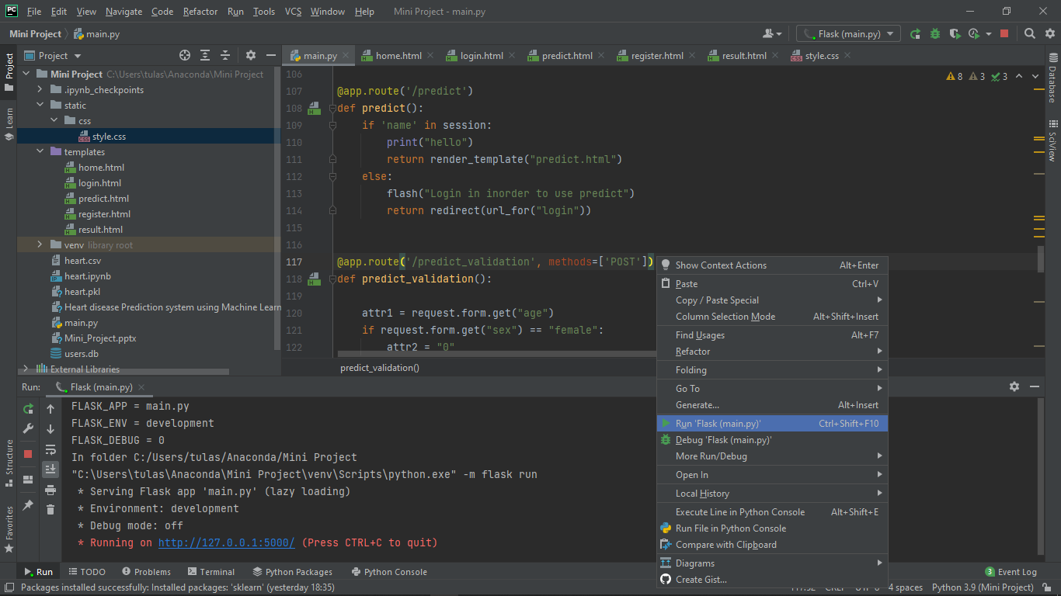

**Fig 47: Run flask**

**4.Home Page**

The home page includes two options for the user. The user can either REGISTER (if you are a new user) or LOGIN(if you already are a registered user).



**Fig 48: Home Page**

**6.Register Page**

Once the user selects the “Register” option in the home page , it prompts the user to the Register Page. Here the user is required to enter their details which are stored into the database. Once registered he can either login or go back to the Home Page.



**Fig 49: Register Page**

**7.Login Page**

A registered user when selects the “login” option in the home page, it prompts the user to the Login Page. Here the user is required to enter their credentials which are verified against the data in the database. If the information is verified , the user  is directed to the “Enter the diagnosis test values” page else he is asked to recheck his information.

**Fig 50: Login Page**

**8.Prediction Page**

The user is required to enter the test values which are taken by the system.



**Fig 51: Prediction Page**

**9.Logout**

To logout, click on the Logout button at the end of the navigation bar .

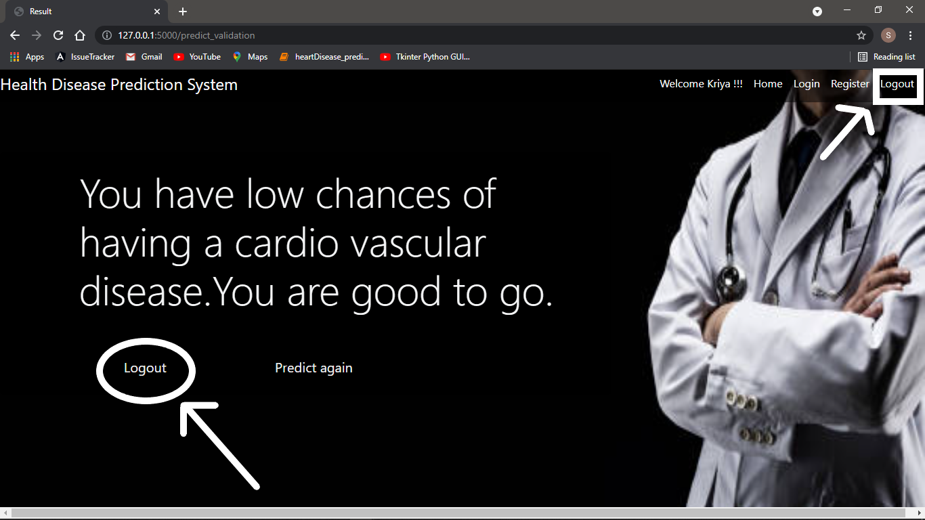

**Fig 52: Logout**